All measurements are of Sa roughness and the units are µm
SDBN1 | Summarised data before erosion of natural enamel measuring 1 cluster
RDBN1 | Raw data before erosion of natural enamel measuring 1 cluster
SDBN4 | Summarised data before erosion of natural enamel measuring 4 clusters
RDBN4 | Raw data before erosion of natural enamel measuring 4 clusters
SDAN1 | Summarised data after erosion of natural enamel measuring 1 clusters
RDAN1 | Raw data after erosion of natural enamel measuring 1 clusters
SDAN4 | Summarised data after erosion of natural enamel measuring 4 clusters
RDAN4 | Raw data after erosion of natural enamel measuring 4 clusters
SDBP1 | Summarised data before erosion of polished enamel measuring 1 cluster
RDBP1 | Raw data before erosion of polished enamel measuring 1 cluster
SDBP4 | Summarised data before erosion of polished enamel measuring 4 clusters
RDBP4 | Raw data before erosion of polished enamel measuring 4 clusters
SDAP1 | Summarised data after erosion of polished enamel measuring 1 cluster
RDAP1 | Raw data after erosion of polished enamel measuring 1 cluster
SDAP4 | Summarised data after erosion of polished enamel measuring 4 clusters
RDAN4 | Raw data after erosion of polished enamel measuring 4 clusters

Natural enamel
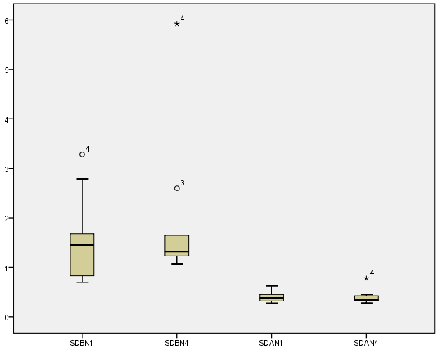

Polished enamel
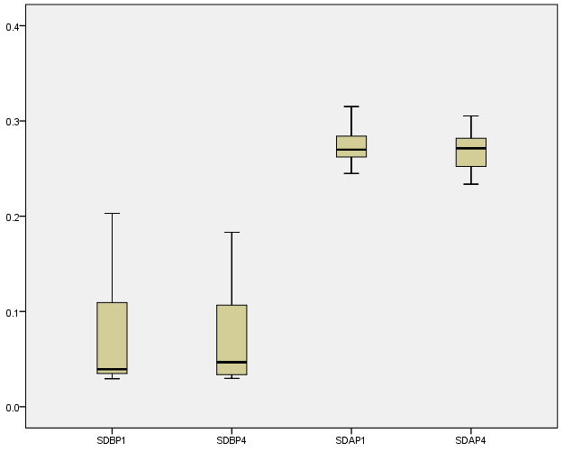

The analysis provides evidence for a difference in SA after erosion but no difference between SA from 1 cluster compared with 4 clusters. We have no evidence that this is the case in unsampled areas of the sections. The analysis for the polished enamel yields the similar conclusions.The SA values from polished enamel sections before erosion are lower compared with SA from polished enamel sections after erosion (the reverse finding for natural enamel). This is easily seen in the boxplots for natural and polished enamel sections.
The Friedman test (the equivalent of the repeated measures ANOVA has been used for these skewed data) has been used with post-hoc by multiple comparisons using paired Wilcoxon test. Bonferroni correction for multiple comparisons (for significant difference, p<0.008333)
Natural enamel sectionsTest Statisticsª
 | SDBN4 - SDBN1 | SDAN4 - SDAN1 | SDAN1 - SDBN1 | SDAN4 - SDBN1 | SDAN4 - SDBN4 | SDAN1 - SDBN4
Z | -1.274^{b} | -.764^{c} | -2.803^{c} | -2.803^{c} | -2.803^{c} | -2.803^{c}
Asymp. Sig. (2-tailed) | .203 | .445 | .005 | .005 | .005 | .005
a. Wilcoxon Signed Ranks Test
b. Based on negative ranks.
c. Based on positive ranks.

SDBN4 - SDBN1
Test Statisticsª
 | all_Sa_data
Mann-Whitney U | 45.000
Wilcoxon W | 100.000
Z | -.378
Asymp. Sig. (2-tailed) | .705
Exact Sig. [2*(1-tailed Sig.)] | .739^{b}
a. Grouping Variable: Groupingfactor
b. Not corrected for ties.

SDAN1 - SDBN4
Test Statisticsª
 | all_Sa_data
Mann-Whitney U | 45.000
Wilcoxon W | 100.000
Z | -.378
Asymp. Sig. (2-tailed) | .705
Exact Sig. [2*(1-tailed Sig.)] | .739^{b}
a. Grouping Variable: Groupingfactor
b. Not corrected for ties.

Descriptive Statistics
 | N | Mean |  | Std. Deviation | Minimum | Maximum
SDBN1 | 10 | 1.550627931450000 |  | .868026061837249 | .6965184406400000 | 3.2801710802000000
SDBN4 | 10 | 1.899904460025036 |  | 1.478646202817847 | 1.0634645578200002 | 5.9210976768300000
SDAN1 | 10 | .393229537309000 |  | .098989618894761 | .2791638042200000 | .6250248565200000
SDAN4 | 10 | .397890917671385 |  | .141811436612859 | .2808990048000000 | .7748093607368420
Ranks
 | Mean Rank
SDBN1 | 3.40
SDBN4 | 3.60
SDAN1 | 1.50
SDAN4 | 1.50

Test Statisticsª
N | 10
Chi-Square | 24.120
df | 3
Asymp. Sig. | .000024
a. Friedman Test
There is a statistically significant difference between the 4 groups of natural enamel sections (p<0.0001).

Natural enamel sections Descriptive Statistics
 | N | Mean | Std. Deviation | Minimum | Maximum | Percentiles
 |  |  |  |  |  | 25th | 50th (Median) | 75th
SDBN1 | 10 | 1.550627931450000 | .868026061837249 | .6965184406400000 | 3.2801710802000000 | .816236385285000 | 1.454276517300000 | 1.953663837700000
SDAN1 | 10 | .393229537309000 | .098989618894761 | .2791638042200000 | .6250248565200000 | .317566124680000 | .380031097350000 | .448398850510000
SDBN4 | 10 | 1.899904460025036 | 1.478646202817847 | 1.0634645578200002 | 5.9210976768300000 | 1.212627907150132 | 1.317758308270395 | 1.883738775900000
SDAN4 | 10 | .397890917671385 | .141811436612859 | .2808990048000000 | .7748093607368420 | .323571292764539 | .342154036575833 | .427141357621032

Polished enamel sections

Descriptive Statistics
 | N | Mean | Std. Deviation | Minimum | Maximum | Percentiles
 |  |  |  |  |  | 25th | 50th (Median) | 75th
SDBP1 | 10 | .077596140585150 | .064075822287434 | .0294850212580000 | .2030449040000000 | .033657407017500 | .039404446881750 | .125563861437500
SDBP4 | 10 | .075663020954650 | .056173505571300 | .0298345580000000 | .1830948337663158 | .033065193087500 | .046716785124342 | .119743405286875
SDAP1 | 10 | .272948924385000 | .019153772896057 | .2448703421400000 | .3150899825000000 | .261517127032500 | .269838747730000 | .284567353910000
SDAP4 | 10 | .268106928543997 | .021773558952940 | .2336839636800000 | .3052946514263158 | .249583793806250 | .271257945089722 | .283492624950066

Ranks
 | Mean Rank
SDBP1 | 1.50
SDBP4 | 1.50
SDAP1 | 3.50
SDAP4 | 3.50

Test Statisticsª
N | 10
Chi-Square | 24.000
df | 3
Asymp. Sig. | .000025
a. Friedman Test
There is a statistically significant difference between the 4 groups of polished enamel sections (p<0.0001).

Test Statisticsª
 | SDBP4 - SDBP1 | SDAP1 - SDBP1 | SDAP4 - SDBP1 | SDAP1 - SDBP4 | SDAP4 - SDBP4 | SDAP4 - SDAP1
Z | -.153^{b} | -2.803^{c} | -2.803^{c} | -2.803^{c} | -2.803^{c} | -.357^{b}
Asymp. Sig. (2-tailed) | .878 | .005 | .005 | .005 | .005 | .721
a. Wilcoxon Signed Ranks Test
b. Based on positive ranks.
c. Based on negative ranks.

SDBP4 - SDBP1
Ranks
 | Groupingfactor | N | Mean Rank | Sum of Ranks
all_Sa_data | 5.00 | 10 | 10.35 | 103.50
 | 6.00 | 10 | 10.65 | 106.50
 | Total | 20

Test Statisticsª
 | all_Sa_data
Mann-Whitney U | 48.500
Wilcoxon W | 103.500
Z | -.113
Asymp. Sig. (2-tailed) | .910
Exact Sig. [2*(1-tailed Sig.)] | .912^{b}
a. Grouping Variable: Groupingfactor
b. Not corrected for ties.

SDAP4 - SDAP1
Test Statisticsª
 | all_Sa_data
Mann-Whitney U | 45.000
Wilcoxon W | 100.000
Z | -.378
Asymp. Sig. (2-tailed) | .705
Exact Sig. [2*(1-tailed Sig.)] | .739^{b}
a. Grouping Variable: Groupingfactor
b. Not corrected for ties.

