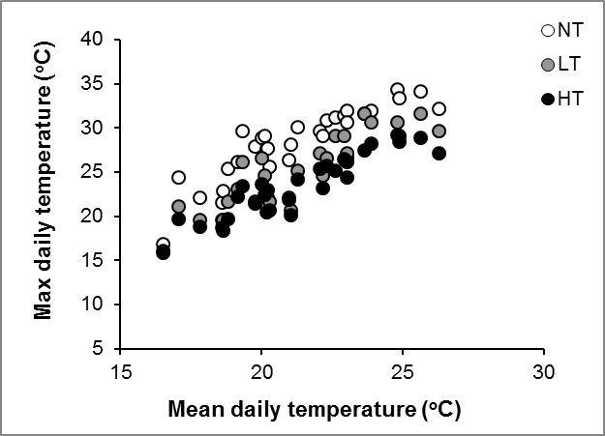

Figure S2. Tree density effects on subsurface temperature. Relationship between the mean daily temperature in control mesocosms and the maximum daily temperatures for all mesocosms in July 2010. Measurements were taken 1 cm below the moss surface in the middle of 1 (low density) or 2 (control and high density) mesocosms of the same block. Standard errors between replicates remained below 5%. Grey tones indicate different tree densities.

