S1 Fig. Details of inter trait correlation under recommended nitrogen in wet season (1-A), recommended nitrogen in dry season (1-B), nitrogen use efficiency indices in wet season (1-C) and nitrogen use efficiency indices in dry season (1-D)
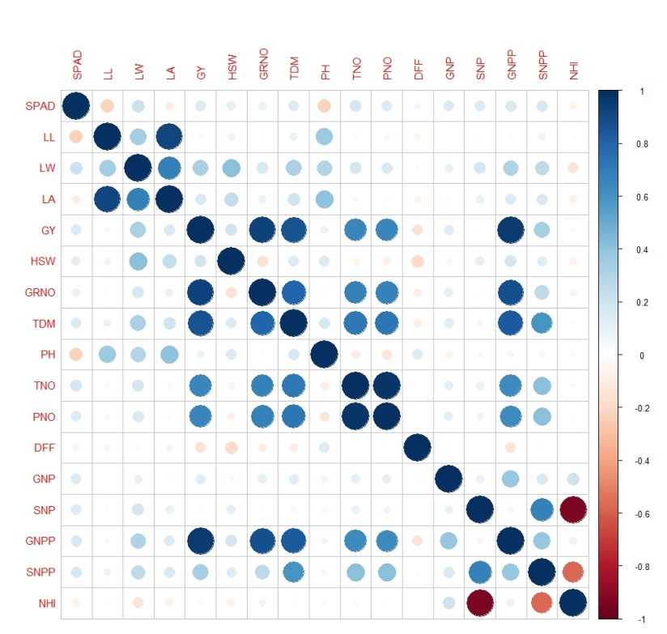
1-A
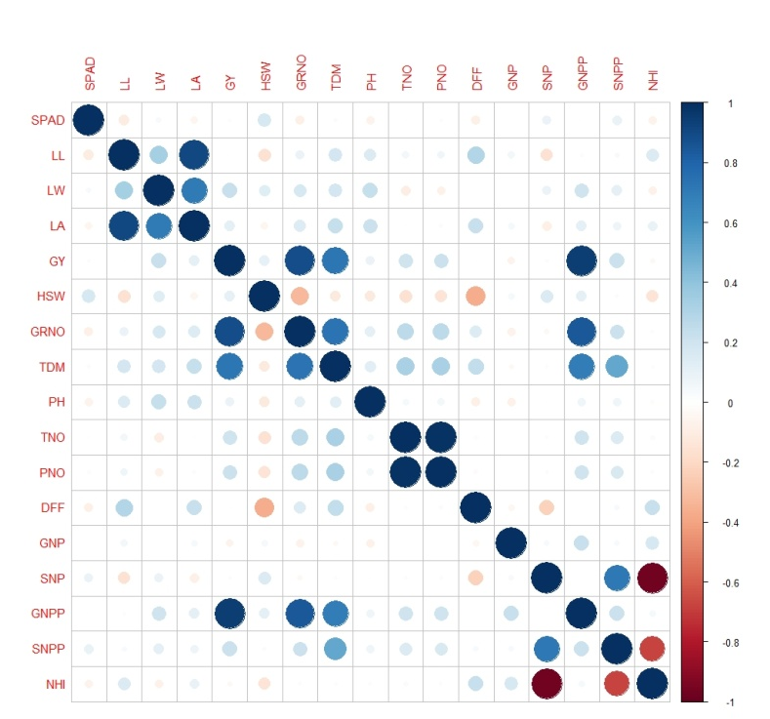
1-B
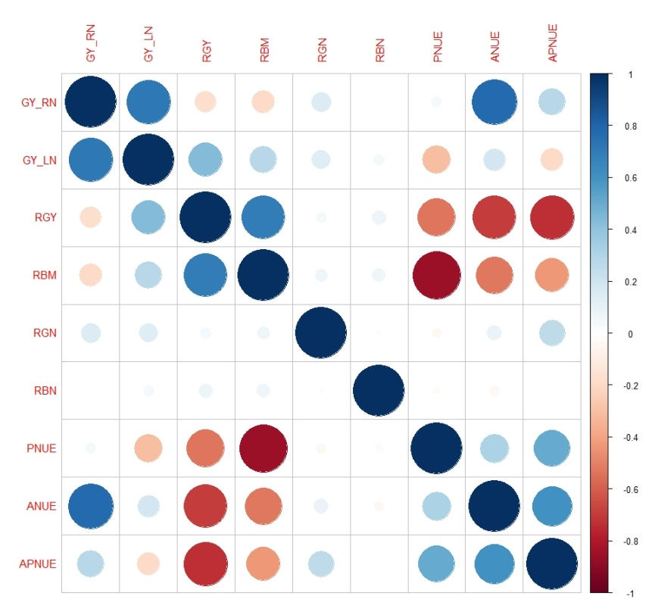
1-C
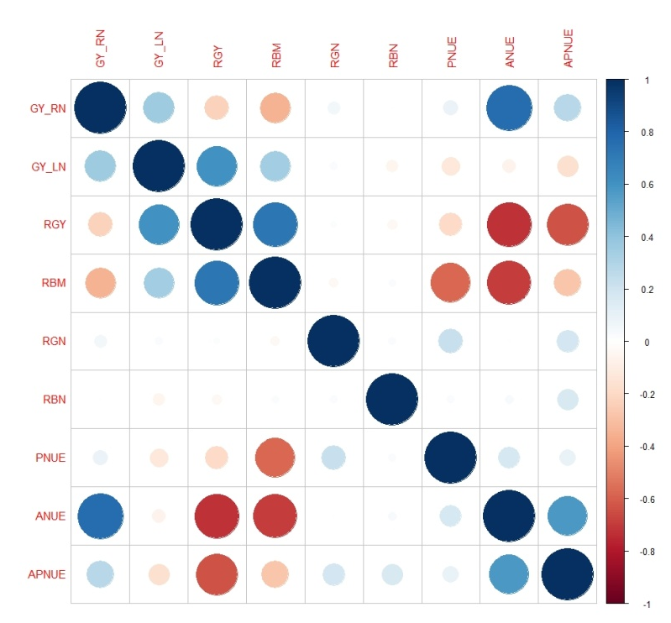
1-D
SPAD: SPAD value, LL: leaf length (cm), LW: leaf width (cm), LA: leaf area (cm), DFF: days to 50% flowering, PH: plant height (cm), TNO: tiller number, PNO: panicle number: GRNO: grain number, HSW: hundred seed weight (g), GY: grain yield per plant (g/plant), TDM: total dry matter (g/plant), GNP: grain nitrogen percent, SNP: straw nitrogen percent, GNPP: grain nitrogen/ plant, SNPP: straw nitrogen/ plant, NHI: nitrogen harvest index, RGY: relative grain yield, RBM: relative biomass yield, RGN: relative grain nitrogen, RBN: relative biomass nitrogen, PNUE: physiological nitrogen use efficiency, ANUE: agronomic nitrogen use efficiency, APE: agro-physiological efficiency

