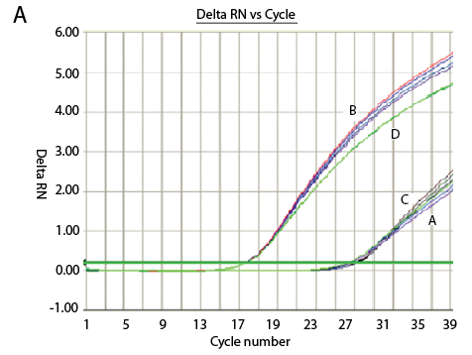
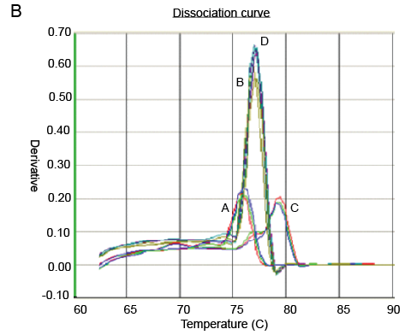
Figure S2. Result of Real-time RT-PCR with pooled primers and N4 RNA template. RNA was extracted from H8N4 AIV-infected allantoid fluids. The amplification curves (part A) showed positive amplification in B and D reactions of the primer-pooled real-time RT-PCR, while negatives in A and C reactions. The dissociation curves (part B) of B and D reactions are distinct from those of A and C reactions.

