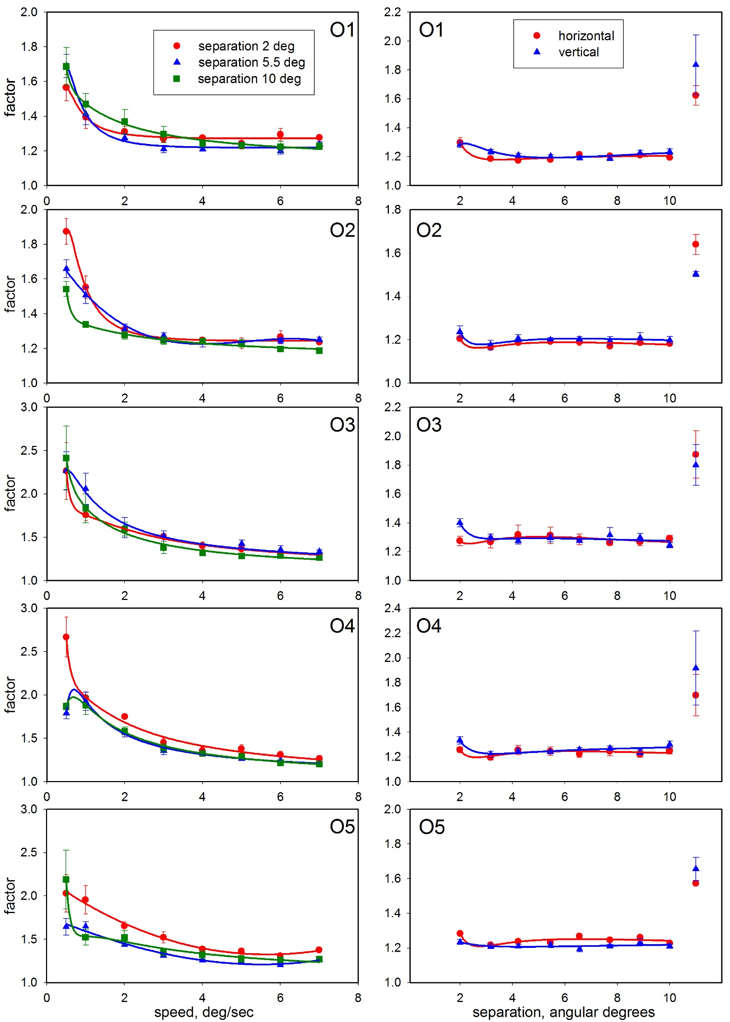

Supplementary Figure 1. Left-hand panels: Results for individual observers in the preliminary experiment on horizontal motion. Error bars show ± standard error of the mean. Other details as for Fig 1b. Right-hand panels: Results for individual observers for speed discrimination as a function of spatial separation in Experiments (i) and (ii). Other details as for Fig 2a.

