Table S1 in file S1. Detection of FMDV in samples from infected animals during the FMDV outbreak Egypt 2012 using real-time RT-PCR and RT-RPA.
No. | Sample Code | Species | Sample Type | Serotype  (By sequencing) | PCR-eg | PCR-de | RPA-Twist | RPA- Roche
 |  |  |  |  | CT | CT | min | min
1 | C2 | CATTLE | S | SAT2 | 28.36 | 22.98 | 5.3 | 5.7
2 | C3 | CATTLE | E | SAT2 | 23.23 | 28.33 | 5.7 | 5.7
3 | C4 | CATTLE | E | SAT2 | 23.66 | 19.16 | 5.3 | 5.3
4 | C5 | CATTLE | B | NA | 25.89 | 19.5 | 5.3 | 5.3
5 | C6 | BUFFALOE | S | SAT2 | 35.85 | 32.36 | Neg | 11
6 | C7 | CATTLE | H | SAT2 | 21.72 | 20.88 | 5.3 | 5.3
7 | C8 | CATTLE | E | SAT2 | 25.32 | 22.87 | 5.3 | 5.3
8 | C9 | CATTLE | S | SAT2 | 31.32 | 27.81 | 6 | 8.3
9 | C10 | CATTLE | H | SAT2 | 23.73 | 19.3 | 5.3 | 5.3
10 | C11 | CATTLE | E | SAT2 | 19.28 | 12 | 3.7 | 3.7
11 | C12 | CATTLE | E | A | 18.27 | 19.1 | 5.3 | 5.3
12 | C13 | CATTLE | E | SAT2 | 26.85 | 27.1 | 6 | 5.3
13 | C14 | CATTLE | E | SAT2 | 35.72 | 24.24 | 6 | 5.7
14 | C15 | CATTLE | E | SAT2 | 27.56 | 24.702 | 9.3 | 6
15 | C16 | CATTLE | E | SAT2 | 31.41 | 25.13 | 6.7 | 5.7
16 | B1 | CATTLE | E | NA | 39.17 | 31.39 | Neg | 10
17 | B2 | CATTLE | E | NA | Neg | 31.97 | Neg | Neg
18 | B3 | CATTLE | E | SAT2 | 27.76 | 24.41 | 5.3 | 5.7
19 | B4 | CATTLE | S | SAT2 | Neg | 28.57 | Neg | 6.7
20 | B5 | SHEEP | S | O | Neg | 26.43 | 9 | 6
21 | B6 | CATTLE | H | SAT2 | 32.4 | 27.38 | 9.7 | 8
22 | B7 | BUFFALOE | H | SAT2 | Neg | 27.82 | 6.3 | 5.7
23 | B8 | BUFFALOE | E | NA | 39 | 27.76 | 9 | 6.7
24 | B9 | CATTLE | S | SAT2 | 23.21 | 21.3 | 5.3 | 5.7
25 | B10 | BUFFALOE | E | SAT2 | 33.34 | 25.32 | Neg | 6.3
26 | B11 | BUFFALOE | S | NEG | 34.68 | 31.15 | Neg | 12.7
27 | B12 | BUFFALOE | S | SAT2 | 34.19 | 29.37 | Neg | 10.3
28 | B13 | CATTLE | E | SAT2 | 32.75 | 27.88 | Neg | 12.3
29 | B14 | BUFFALOE | E | SAT2 | 24.6 | 24.65 | 5.7 | 6
30 | B15 | CATTLE | E | POS | 31.75 | 29.43 | Neg | 6.3
31 | B16 | CATTLE | S | SAT2 | 30.89 | 31.94 | Neg | 7.7
32 | F1 | CATTLE | E | N/A | 22.6 | 32.99 | Neg | 5.7
33 | F2 | CATTLE | E | N/A | 29.5 | 27.55 | Neg | 6
34 | F3 | CATTLE | S | N/A | 29.9 | 21.37 | 6 | 6
35 | F4 | CATTLE | B | N/A | 33.8 | 21.32 | 6 | 5.3
36 | F5 | CATTLE | B | N/A | 31 | 26.45 | 6 | 6
37 | F6 | CATTLE | B | N/A | 31.7 | 25.5 | 6 | 6
38 | F7 | CATTLE | B | N/A | 20.4 | 29.62 | 6 | 5.3
39 | F8 | CATTLE | S | N/A | 42.5 | 30.22 | Neg | 6
40 | F9 | CATTLE | S | N/A | 32.6 | 33.88 | Neg | 6
41 | F10 | CATTLE | M | N/A | 34.78 | 32.82 | Neg | 6
42 | F11 | CATTLE | M | N/A | 35.33 | 39.65 | Neg | 7
43 | F12 | CATTLE | M | N/A | Neg | 31.17 | Neg | 7.7
44 | F14 | CATTLE | B | N/A | 35.64 | 30.82 | 8 | 9.3
45 | F15 | CATTLE | B | N/A | 35.33 | 29.98 | 9.7 | 8
E, vesicular material; S, saliva; H, heart: B, blood; M, milk; Neg, negative; N/A, not applicable; PCR-eg, RT-PCR as described [8]; RPA-Twist, RT-RPA using RT exo kits from Twist Dx™ (TwistDx, Cambridge, UK); PCR-de, RT-PCR as described [12]; RPA-Roche, RT-RPA with exo kits from Twist DxTM but using RT from Roche (Roche, Mannheim, Germany); CT, cycle threshold

Table S2 in file S1. GC content of the RPA forward and reverse primers.
Name | AT content | GC content | GC% | GC at 5´ | RPA sensitivity
F01 | 16 | 13 | 44.8 | 2 | N/A
F02 | 20 | 13 | 39.3 | 2 | N/A
F03 | 18 | 12 | 40 | 2 | N/A
F04 | 20 | 14 | 41.1 | 3 | 1.00E+02
F05 | 16 | 14 | 46.6 | 2 | N/A
F06 | 16 | 14 | 46.6 | 2 | N/A
F07 | 15 | 15 | 50 | 3 | N/A
F08 | 17 | 13 | 43.3 | 2 | N/A
F09 | 19 | 11 | 36.6 | 1 | N/A
F10 | 19 | 11 | 36.6 | 0 | N/A
F11 | 17 | 13 | 40 | 1 | N/A
F12 | 20 | 12 | 39.9 | 2 | N/A
F13 | 21 | 13 | 38.2 | 2 | N/A
F14 | 21 | 14 | 40 | 3 | 1.00E+03
F15 | 22 | 14 | 38.8 | 2 | 1.00E+2 -1.00E+03
F16 | 17 | 11 | 39.2 | 2 | N/A
F17 | 16 | 11 | 40.7 | 2 | N/A
F18 | 15 | 11 | 42.3 | 2 | N/A
F19 | 14 | 9 | 39.1 | 2 | N/A
R01 | 13 | 19 | 59.3 | 2 | N/A
R02 | 14 | 17 | 54.8 | 3 | N/A
R03 | 14 | 19 | 57.5 | 1 | N/A
R04 | 12 | 22 | 64.7 | 3 | N/A
R05 | 12 | 23 | 65.7 | 3 | N/A
R06 | 13 | 18 | 58 | 4 | N/A
R07 | 14 | 17 | 54.8 | 4 | 1.00E+03
R08 | 13 | 18 | 58 | 4 | N/A
R09 | 12 | 19 | 61.2 | 3 | 1.00E+03
R10 | 11 | 20 | 64.5 | 4 | N/A
R11 | 11 | 20 | 64.5 | 3 | N/A
R12 | 14 | 18 | 56.2 | 4 | N/A
R13 | 13 | 17 | 56.6 | 5 | N/A
R14 | 13 | 16 | 55.1 | 4 | N/A
R15 | 13 | 15 | 53.5 | 4 | 1.00E+03
R16 | 13 | 14 | 51.8 | 3 | N/A
R17 | 13 | 13 | 50 | 3 | N/A
R18 | 13 | 12 | 48 | 3 | N/A
R19 | 12 | 12 | 50 | 3 | 1.00E+03
R20 | 12 | 11 | 47.8 | 3 | 1.00E+02

F, forward primer; R, reverse primer; N/A, not applicable

Figure S1 in file S1. FMDV RT-RPA primers and probe sequences. Nineteen forward primers (F), 4 probes (P), and 20 reverse primers (R) were tested to select combinations yielding the highest analytical RPA sensitivity. NNN are sites of the quencher and fluropohore in following order (BHQ1-dT) (Tetrahydrofuran) (FAM-dT). LNA is probe containing locked nucleic acid (Bold and underlined). RC is the reverse complementary of the original sequence used in the experiment.

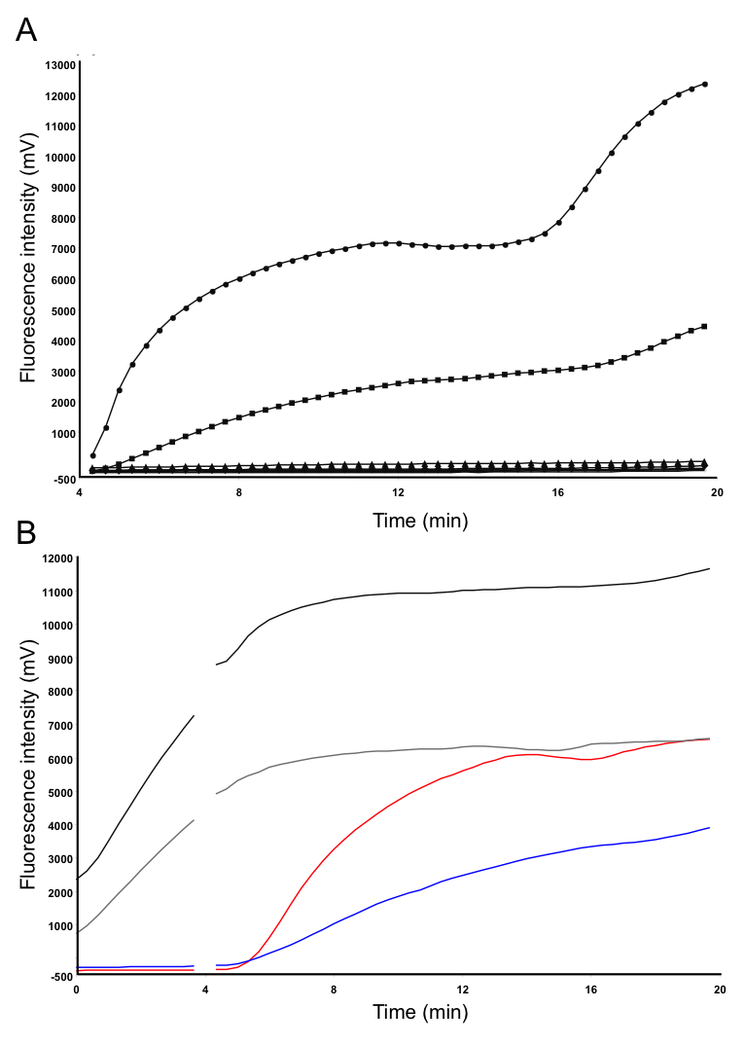
Figure S2 in file S1. The FMDV RT-RPA sensitivity with probes containing LNA nucleotide. Fluorescence development over time using a dilution range of 10⁷-10¹ molecules/µl of the FMDV RNA standard (Graph generated by ESEquant tubescanner software). A: F04+R20+P3 were used for the amplification and detection steps and the sensitivity was 10⁶. 10⁷ represented by dot; 10⁶, box; 10⁵, triangular; 10⁴, diamond; 10³, star; 10², vertical-line; 10¹, horizontal-line; negative control, plane line. B: grey line is control negative with F04+R20+P4; black, F04+R20+P4+10⁵ of FMDV molecular standard; red, F04+R20+P2+10⁵ of FMDV molecular standard; blue, F04+R20+P3+10⁵ of FMDV molecular standard.

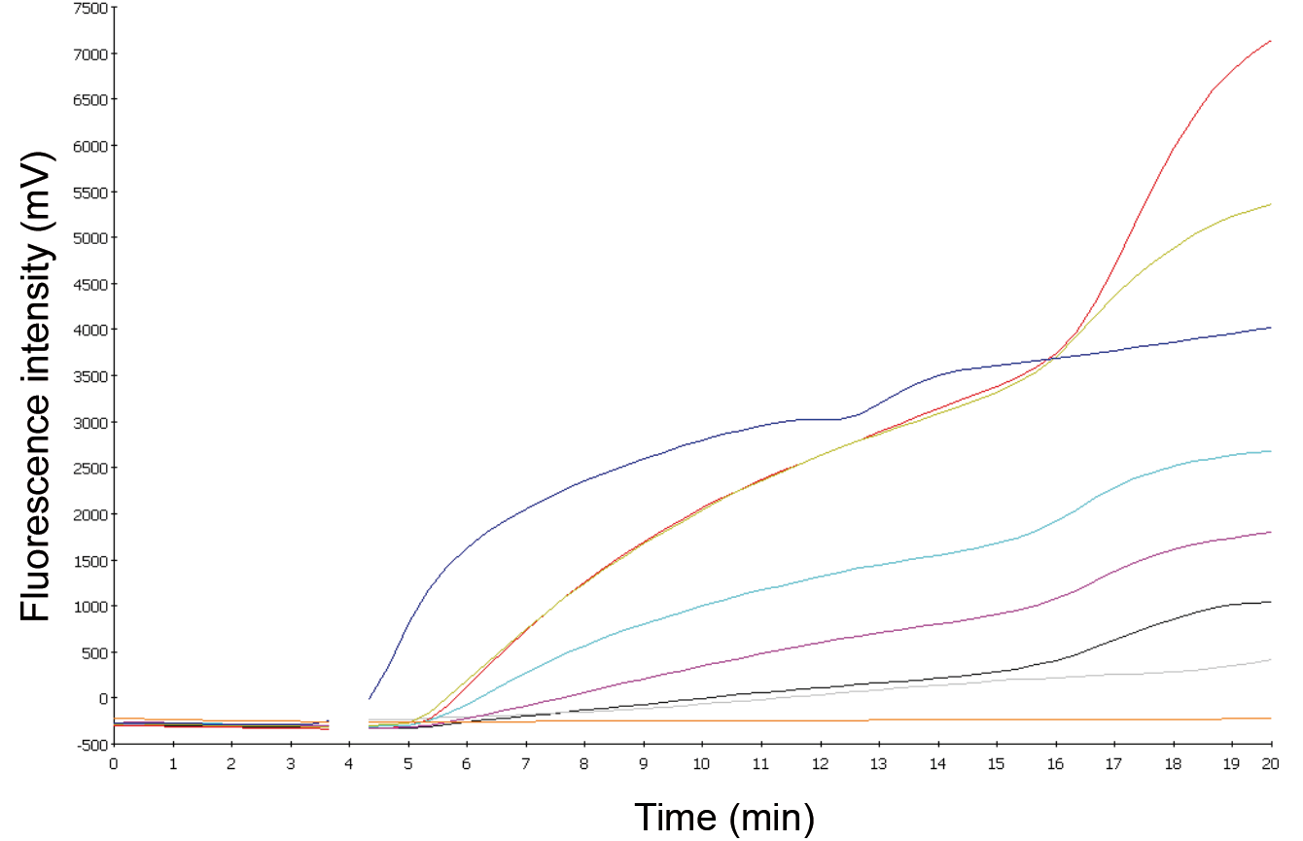
Figure S3 in file S1. The performance of the FMDV RT-RPA assay on RNA of serotypes O (Manisa, orange; BFS, dark khaki), SAT1 (SAT1 Zimb22/89, magenta), SAT2 (SAT2 Egypt 6/2012, cyan), C (C Oberbayern, black), and A (A22 Iraq 24/64, gray). Blue is the positive control (synthetic FMDV RNA) and orange is the negative control.

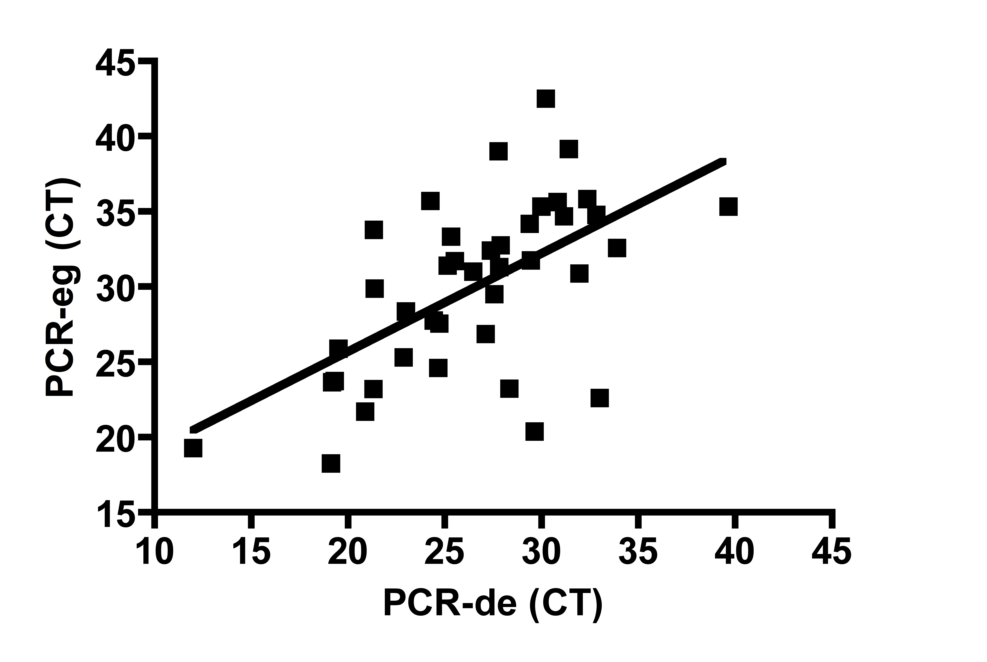
Figure S4 in file S1. Comparison between real-time PCR.eg and PCR.de for the detection of FMDV in clinical samples During Egypt 2012 FMD outbreak. Forty-five RNA extracts of samples collected from suspected cases of FMDV were screened. Linear regression analysis of cycle threshold (CT) values of PCR-eg (Y axis) and PCR-de (X axis) were determined by Prism software. R squared value was 0.35.

Figure S5 in file S1. Secondary structure of RPA primers. Structures were created by Visual OMP program ((DNA software, MI, USA). A, F02: B, F15; C, F04; D, R02; E, R06; F, R20

Figure S6 in file S1. Primer hybridizing to the FMDV standard DNA affects its secondary structure. Structures were created by Visual OMP program ((DNA software, MI, USA). A, FMDV standard negative sense strand (7839-8098 of Genbank accession number JF749843) in unhybridized form: B, hybridized with F04; C, with F08; D, with R20. Primers are in black squares.

