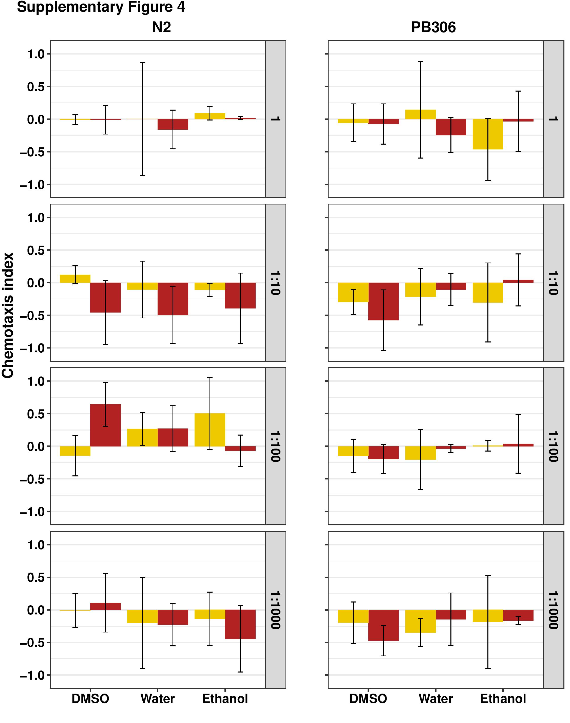
Supplemental Figure 4. C. elegans N2 and PB306 dauers respond neutrally to P. scaber washes at four different concentrations (1, 1:10, 1:100, and 1:1000). Yellow bars represent washes prepared from male isopods. Red bars represent washes prepared from female isopods. Chemotactic indices from all isopod washes were not significantly different from the chemotactic indices of its corresponding neutral control (Supplemental Table 3). Significance scores (p values) are in Supplemental Table 5.

