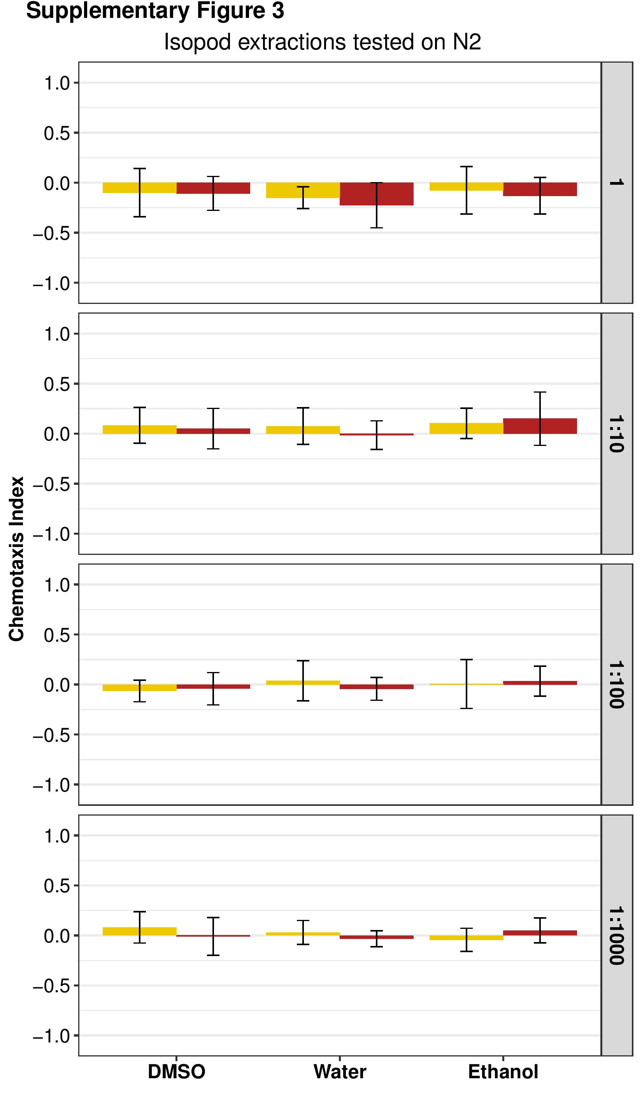
Supplemental Figure 3. C. elegans N2 adults respond neutrally to P. scaber extractions at four different dilutions of the initial extraction (1, 1:10, 1:100, and 1:1000). Yellow bars represent extractions prepared from male isopods. Red bars represent extractions prepared from female isopods. Chemotactic indices from all isopod extractions were not significantly different from the chemotactic indices of its corresponding neutral control (Supplemental Table 1). Significance scores (p values) are in Supplemental Table 5.

