A.
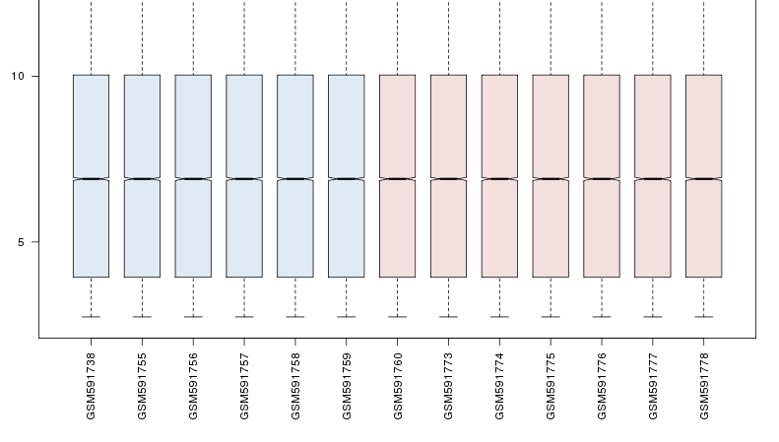
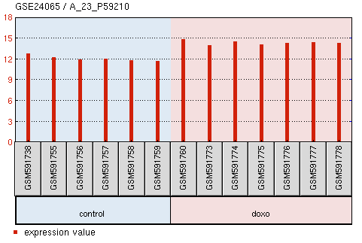
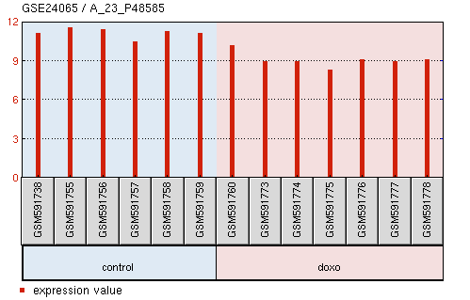
SALL2 CDKN1A Data deviation

B.
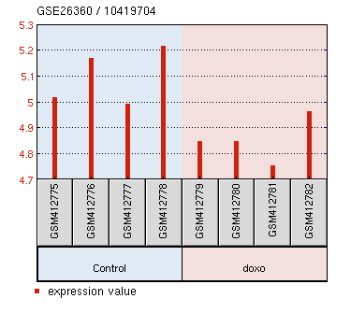
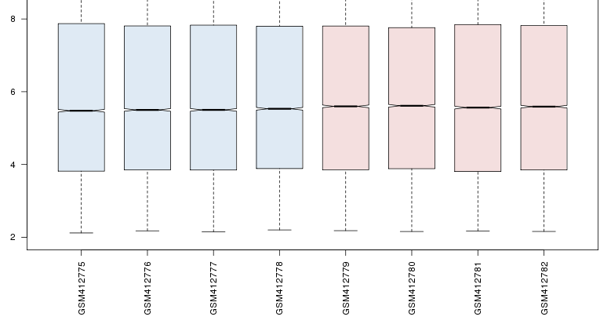
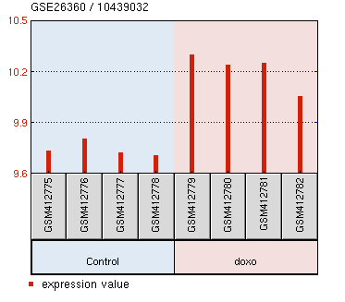
SALL2 CDKN1A Data deviation

C.
Treatment | Factor Value | UP/DOWN | T-statistic | P-value
Doxorubicin | 0.08 μM | DOWN | -3.8 | 0.001
Doxorubicin | 0.4 μM | DOWN | -3.9 | 0.001
Doxorubicin | 2 μM | NONDE | -1.4 | 0.287
Etoposide | 14 μM | NONDE | -1.3 | 0.355
Etoposide | 35 μM | NONDE | -1.3 | 0.355
Etoposide | 70 μM | DOWN | -2.8 | 0.026

Supplementary Figure S4. SALL2 mRNA levels decrease in response to genotoxic agents.

