Table S1. Lower-ranking binding conformations of 1 to NAE and their corresponding docking scores generated by virtual ligand docking.
Conformation | ICM docking score
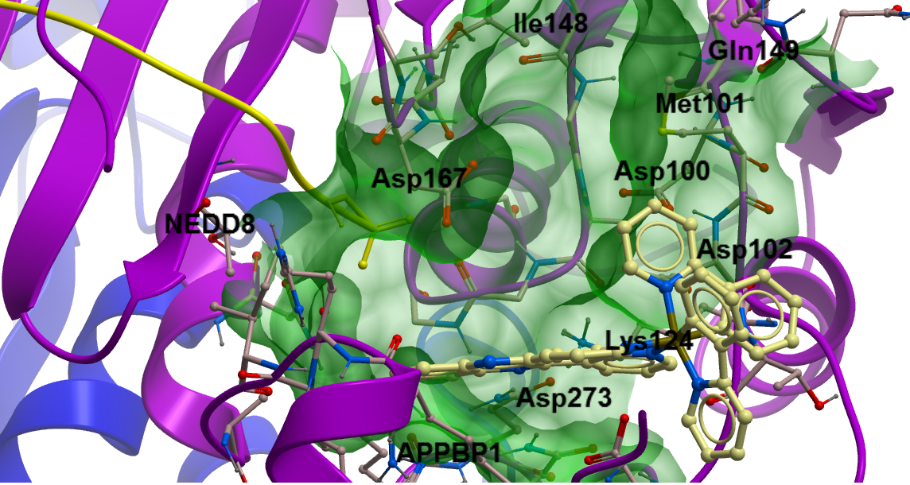 | –28.35
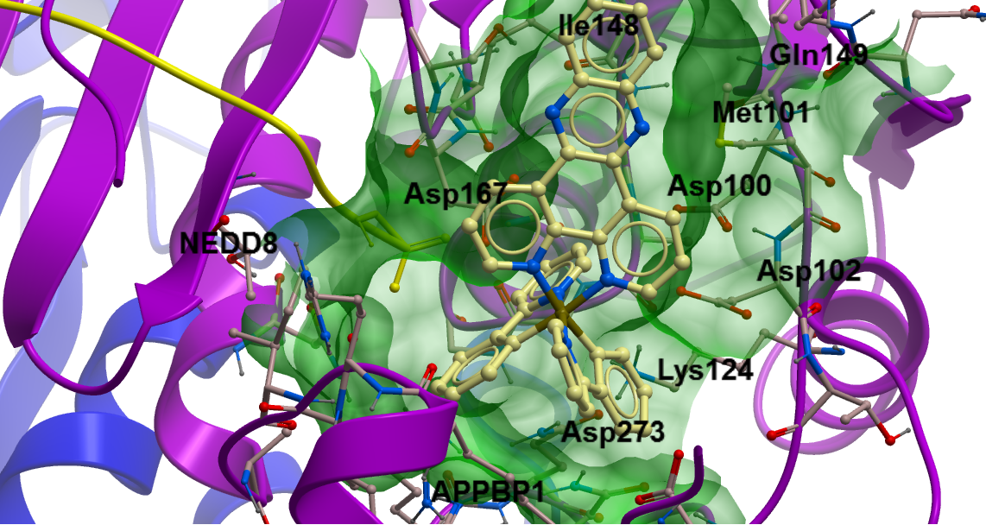 | –25.67
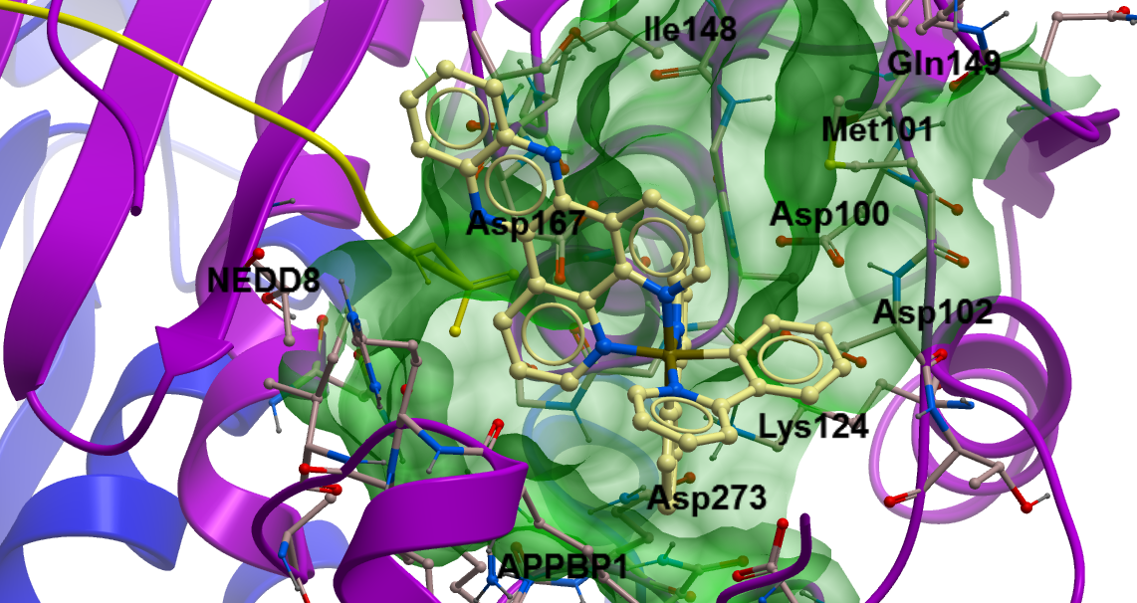 | –24.46

