NIGERIA

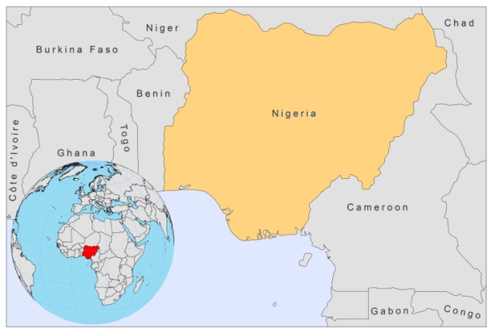

BASIC COUNTRY DATA

Total Population: 158,423,182
Population 0-14 years: 43%
Rural population: 50%
Population living under USD 1.25 a day: no data
Population living under the national poverty line: no data
Income status: Lower middle income economy
Ranking: Low human development (ranking 156)
Per capita total expenditure on health at average exchange rate (US dollar): 69
Life expectancy at birth (years): 51
Healthy life expectancy at birth (years): 42

BACKGROUND INFORMATION

The first case of CL was reported in 1924 [1]. Foci for CL are in the northwestern part and in the Plateau state, located in central Nigeria. An outbreak occurred at a secondary school in Sokoto, in 2003; 10% of the school children were affected [2].

A study in school children from the Plateau area showed that CL was confirmed in 63 out of 1,120 cases [3]. A recent house-to-house survey in this area found CL in 18 (2.6%) of a population of 703 inhabitants of the area [4]. In another study in Kaena, in the Plateau state, 197 (3.9%) of 5,046 inhabitants had CL [5]. CL is likely to be vastly underreported.

In 2010 a CL/HIV co-infection was diagnosed in a 38-year-old woman [6].

PARASITOLOGICAL INFORMATION

Leishmania species | Clinical form | Vector species | Reservoirs
L. major | ZCL | P. duboscqi, P. rodhaini | Unknown

MAPS AND TRENDS

Cutaneous leishmaniasis
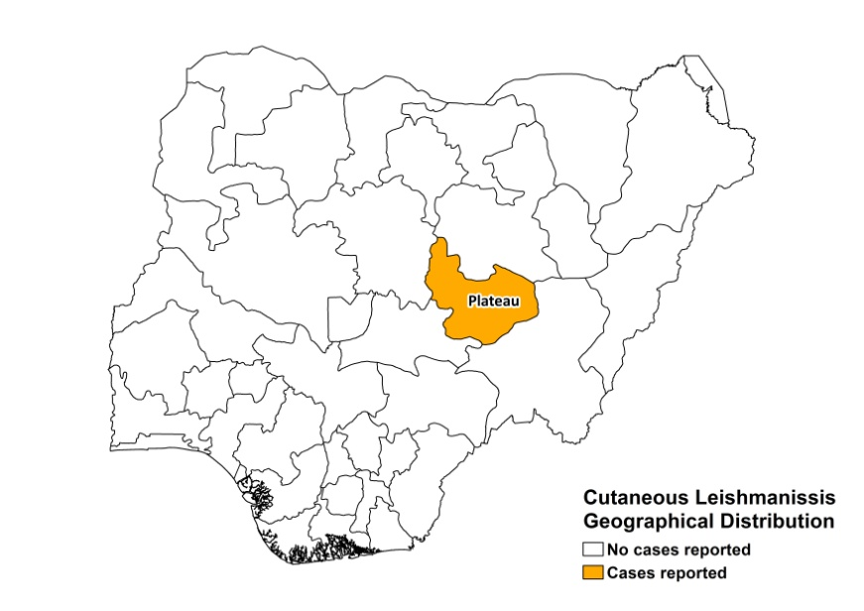

Visceral leishmaniasis trend

Cutaneous leishmaniasis trend

CONTROL, DIAGNOSIS, TREATMENT

No information available.

ACCESS TO CARE

Between 1992 and 1995, two patients died because they did not have access to antimonials in time.

ACCESS TO DRUGS

No antimonials are registered.

SOURCES OF INFORMATION

1. Dyce-Shar (1924). Oriental sore in Nigeria. Trans Roy Soc Trop Med Hyg 1924; 18: 336.

2. Jiya NM, Ahmed H, Jibrin B, Philips AO (2007). An outbreak of Cutaneous Leishmaniasis in a Boarding Senior Secondary School in Sokoto, North Western Nigeria: Clinical Presentation and Outcome. Nigerian Medical Practitioner 5: 86-89.

3 Agwale SM, Dondji B, Okolo CJ, Duhlinska DD (1993). Clinical and parasitological prevalence of leishmaniasis in school children in Keana, Awe, L.G.A. of Plateau State. Nigeria. 1993. Mem Inst Oswaldo Cruz 88:347.

4. Igbe M, Duhlinska D, Agwale S (2009). Epidemiological survey of cutaneous leishmaniasis in Jos East L.G.A. Of Plateau State Nigeria. The Internet Journal of Parasitic Diseases 4 (1).

5. Ike El, Ajayi JA, Bello CSS (1993). Outbreak of human Cutaneous leishmaniasis in Keana District of Plateau State Nigeria. A preliminary communication. Niger Med J 24 (3): 101 – 102.

6. Yusuf SM, Uloko AE, Adamu HA, Iliyasu G, Mohammed AM (2010). Disseminated cutaneous leishmaniasis in HIV positive patient--a case report. Niger J Med 19(1):112-4.

