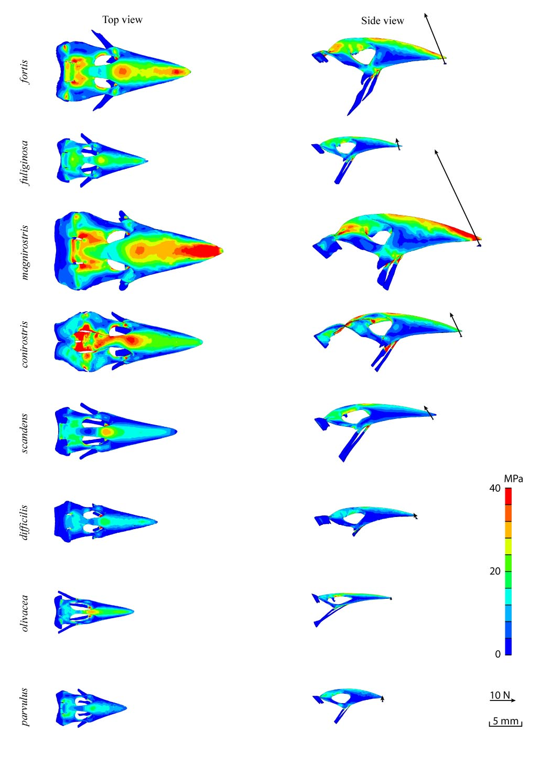
S3 Fig.: Top and side view for physiological FE models of upper beak during tip biting for 8 Darwin finches.

