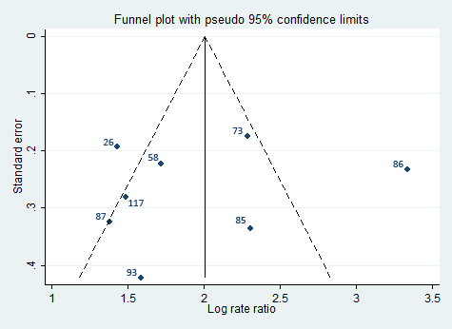
Figure S5: Funnel plot of log relative risk of schizophrenia in black Caribbean migrants and their offspring compared with the baseline population,* by study size

