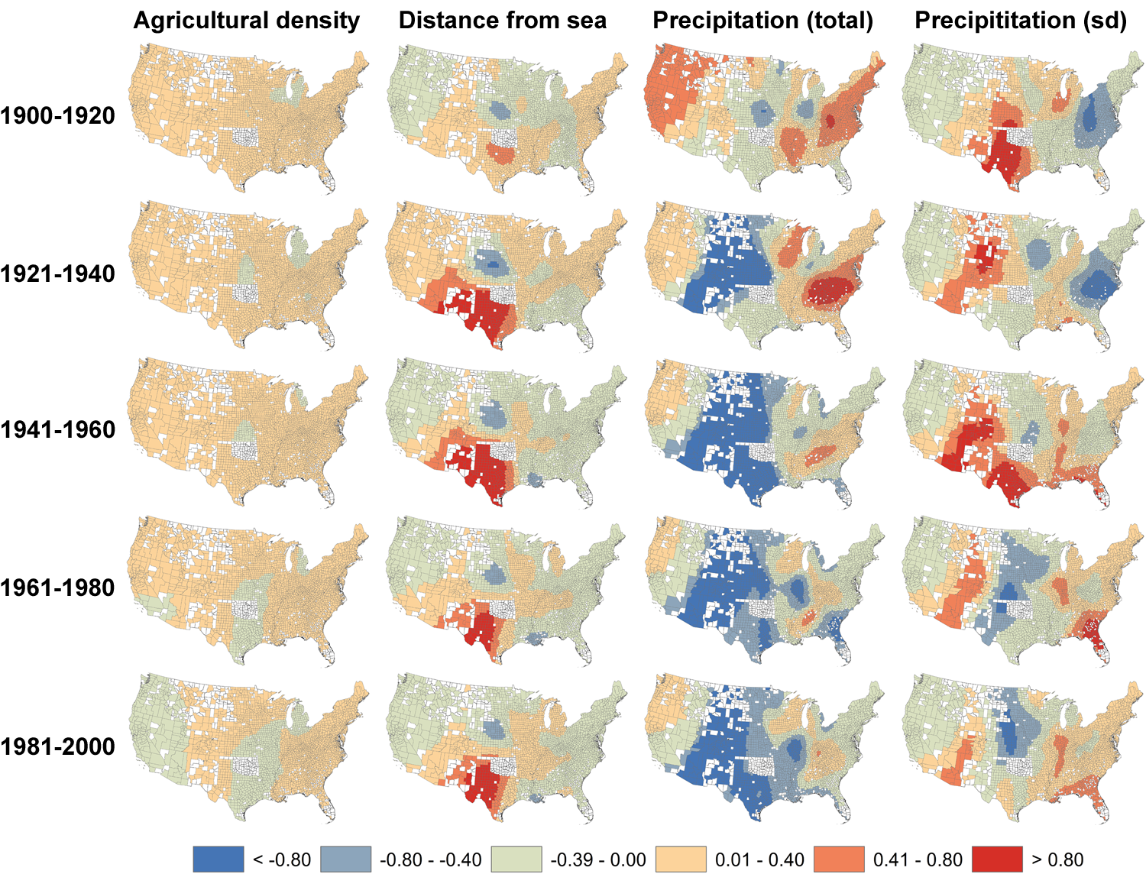

Figure S7. Standardized regression coefficients (Stdβ) of the four least important predictors of demographic growth rates for 2728 U.S. counties in five 20-year intervals during the 20th century (see Fig. 6). Counties shown in white were not included in the analyses because they did not have consistent census data or changed their geographical boundaries during the 20th century. See fig. 6 for the Stdβ of the four other variables used in this analysis.

