 | 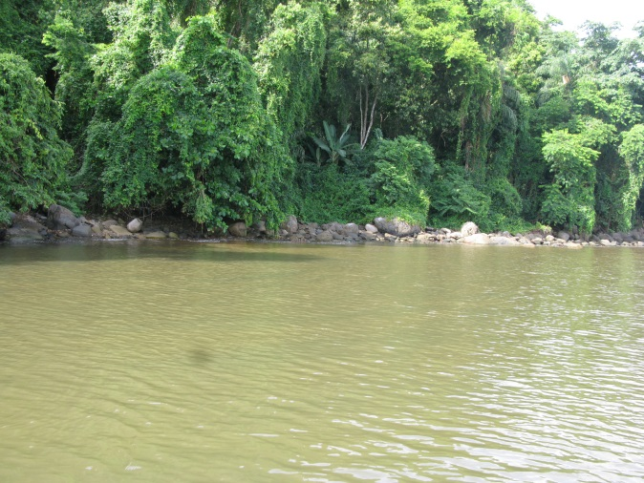
Date: 01-28-2012; before rain | Date: 02-28-2012; after 76 mm rain
S1 Fig.

