TAIWAN, CHINA

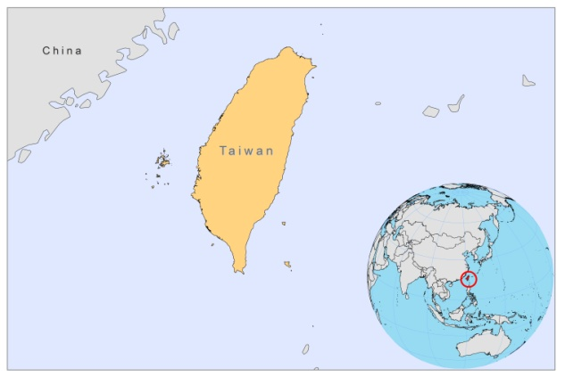

BASIC DATA

Total Population: no data
Population 0-14 years: no data
Rural population: no data
Population living under USD 1.25 a day: no data
Population living under the national poverty line: no data
Income status: no data
Ranking: no data
Per capita expenditure on health at average exchange rate (US dollar): no data
Life expectancy at birth (years): no data
Healthy life expectancy at birth (years): no data

BACKGROUND

Leishmaniasis appeared in Taiwan, China, for the first time in 1942 [1], but was an imported disease, occurring only in soldiers that spent time on mainland China. Over 100 cases of imported VL and PKDL were documented between 1952 and 1958, due to extensive population movement into Taiwan after the Second World War [2]. The first reports of autochtonous CL were in 2 Taiwanese aboriginals in 1968-1970 [2]. In 2008, a later report followed about a patient with a cutaneous nasal lesion, similar to those caused by L.tropica; the causative organism was isolated and concluded to be probable L.tropica [3]. In 2009, three more autochtonous cases of CL were reported [4].

PARASITOLOGICAL INFORMATION

Leishmania species | Clinical form | Vector species | Reservoirs
Unknown | CL, DCL | P. kiangsuensis | Unknown

No further information is available

SOURCES OF INFORMATION

1. Hongyo R (1942) Some observations on the blood and urine of kala-azar; especially on Tomita's urine reaction. Taiwan Igakkai Zassi 41: 279-284.

2. Cross JH, Gunning J-J, Drutz DJ, Lien JC (1985). Autochtonous cutaneous-subcutaneous Leishmaniasis on Taiwan. Am. J. Trop. Med. Hyg. 1985; 34(2), 254-256.

3. Wang JR, Lee ST, Juan WH, Chuang WL, Hung SI et al (2008). Indigenous leishmaniasis in Taiwan: report of a case. Int J Dermatol 47(1):40-3.

4. Lee JY, Hsu MM, Wang CY, Ho JC (2009). Indigenous cutaneous leishmaniasis in Taiwan: three additional cases in southern Taiwan. Int J Dermatol 48(4):441-3.

