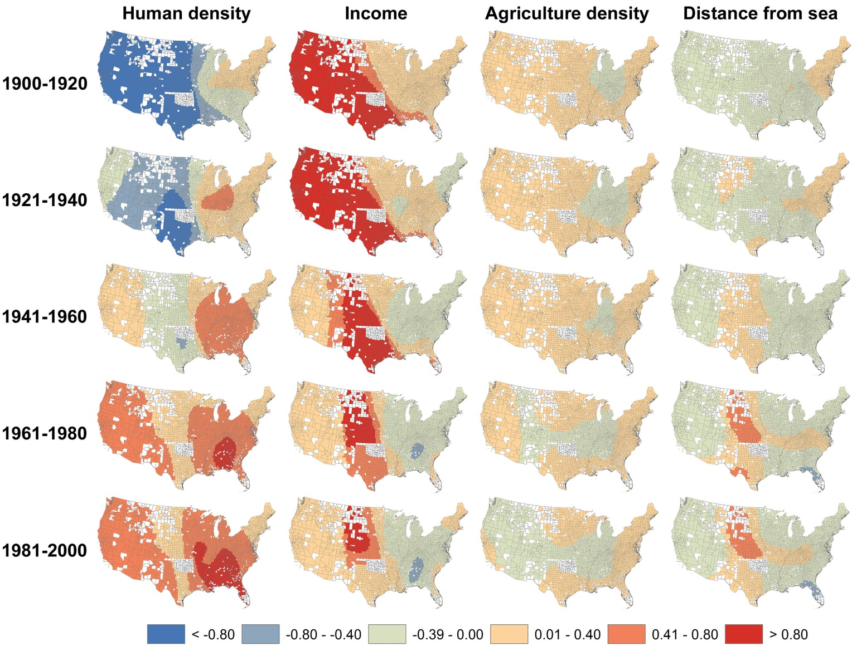

Figure S2. Standardized regression coefficients of socio-economical variables for 2728 U.S. counties during the 20th century estimated with GWR_{NC} models predicting demographic growth rates. White counties were not included in the analyses because they did not have consistent census data or changed their geographical boundaries in the 20th century.

