Forest Plots
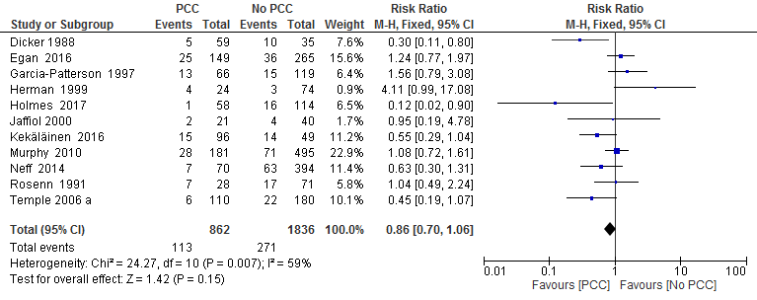
Figure 1. Risk ratio for miscarriage from 11 studies of women with pre-existing diabetes mellitus who did or did not receive preconception care.
The black diamond represents the pooled risk estimate. Heterogeneity is quantified by I² statistics, an I² value ≥ 50 indicates substantial heterogeneity. Estimated results are presented as risk ratio with 95% Confidence Interval. PCC= Preconception care; No PCC= No preconception care; CI= Confidence intervals.

Figure 2. Risk ratio for large for gestational age (LGA)/ macrosomia from nine studies of women with pre-
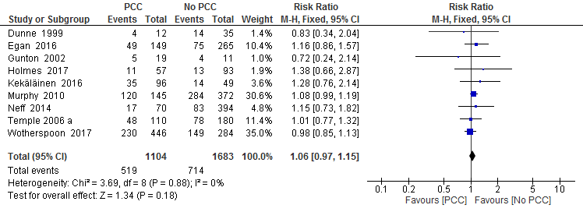
existing diabetes mellitus who did or did not receive preconception care.
The black diamond represents the pooled risk estimate. Heterogeneity is quantified by I² statistics, an I² value ≥ 50 indicates substantial heterogeneity. Estimated results are presented as risk ratio with 95% Confidence Interval. PCC= Preconception care; No PCC= No preconception care; CI= Confidence intervals.

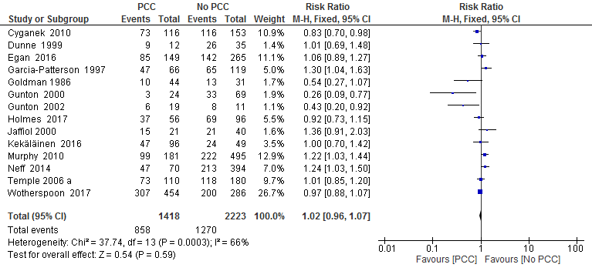
Figure 3. Risk ratio for Caesarean section from 14 studies of women with pre-existing diabetes mellitus who did or did not receive preconception care.
The black diamond represents the pooled risk estimate. Heterogeneity is quantified by I² statistics, an I² value ≥ 50 indicates substantial heterogeneity. Estimated results are presented as risk ratio with 95% Confidence Interval. PCC= Preconception care; No PCC= No preconception care; CI= Confidence intervals.

Figure 4. Risk ratio for neonatal hypoglycaemia from five studies of women with pre-existing diabetes mellitus who did or did not receive preconception care.
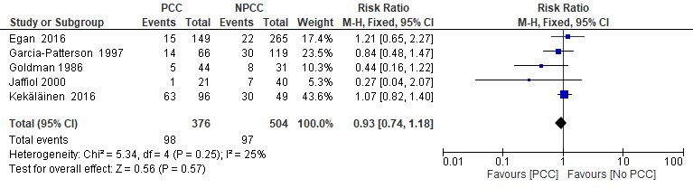
The black diamond represents the pooled risk estimate. Heterogeneity is quantified by I² statistics, an I² value ≥ 50 indicates substantial heterogeneity. Estimated results are presented as risk ratio with 95% Confidence Interval. PCC= Preconception care; No PCC= No preconception care; CI= Confidence intervals.

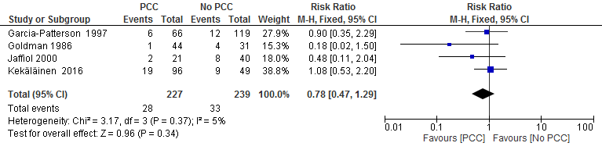
Figure 5. Risk ratio for neonatal respiratory distress from four studies of women with pre-existing diabetes mellitus who did or did not receive preconception care.
The black diamond represents the pooled risk estimate. Heterogeneity is quantified by I² statistics, an I² value ≥ 50 indicates substantial heterogeneity. Estimated results are presented as risk ratio with 95% Confidence Interval. PCC= Preconception care; No PCC= No preconception care; CI= Confidence intervals.

Figure 6. Risk ratio for shoulder dystocia from two studies of women with pre-existing diabetes mellitus who did or did not receive preconception care.
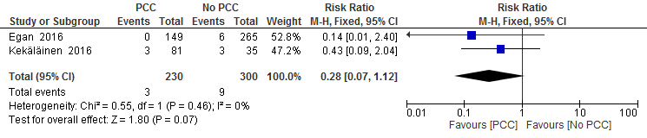
The black diamond represents the pooled risk estimate. Heterogeneity is quantified by I² statistics, an I² value ≥ 50 indicates substantial heterogeneity. Estimated results are presented as risk ratio with 95% Confidence Interval. PCC= Preconception care; No PCC= No preconception care; CI= Confidence intervals.

