Figure S3
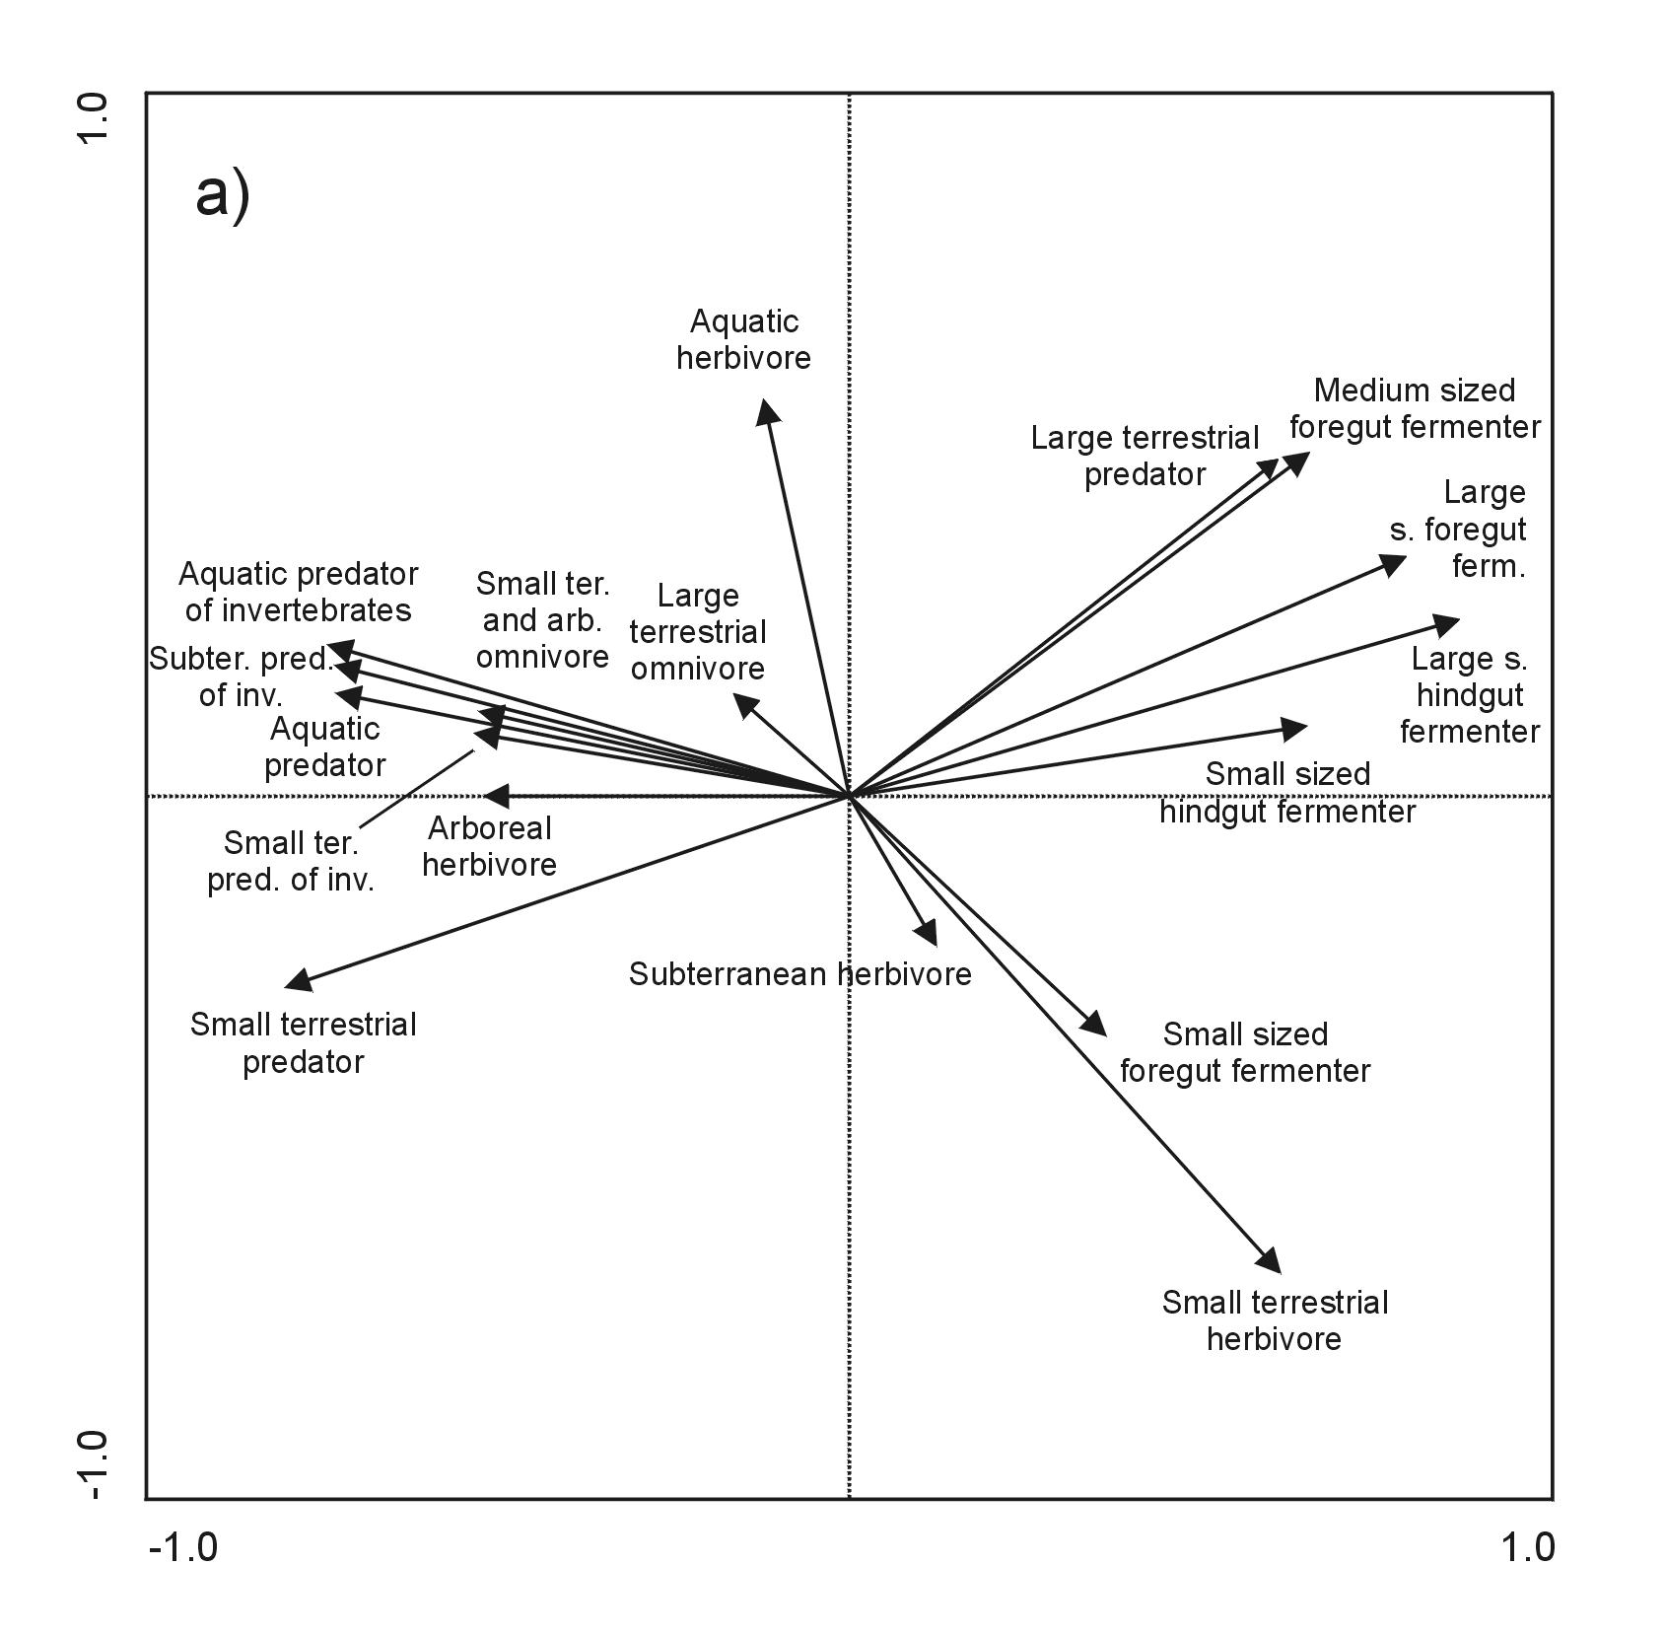

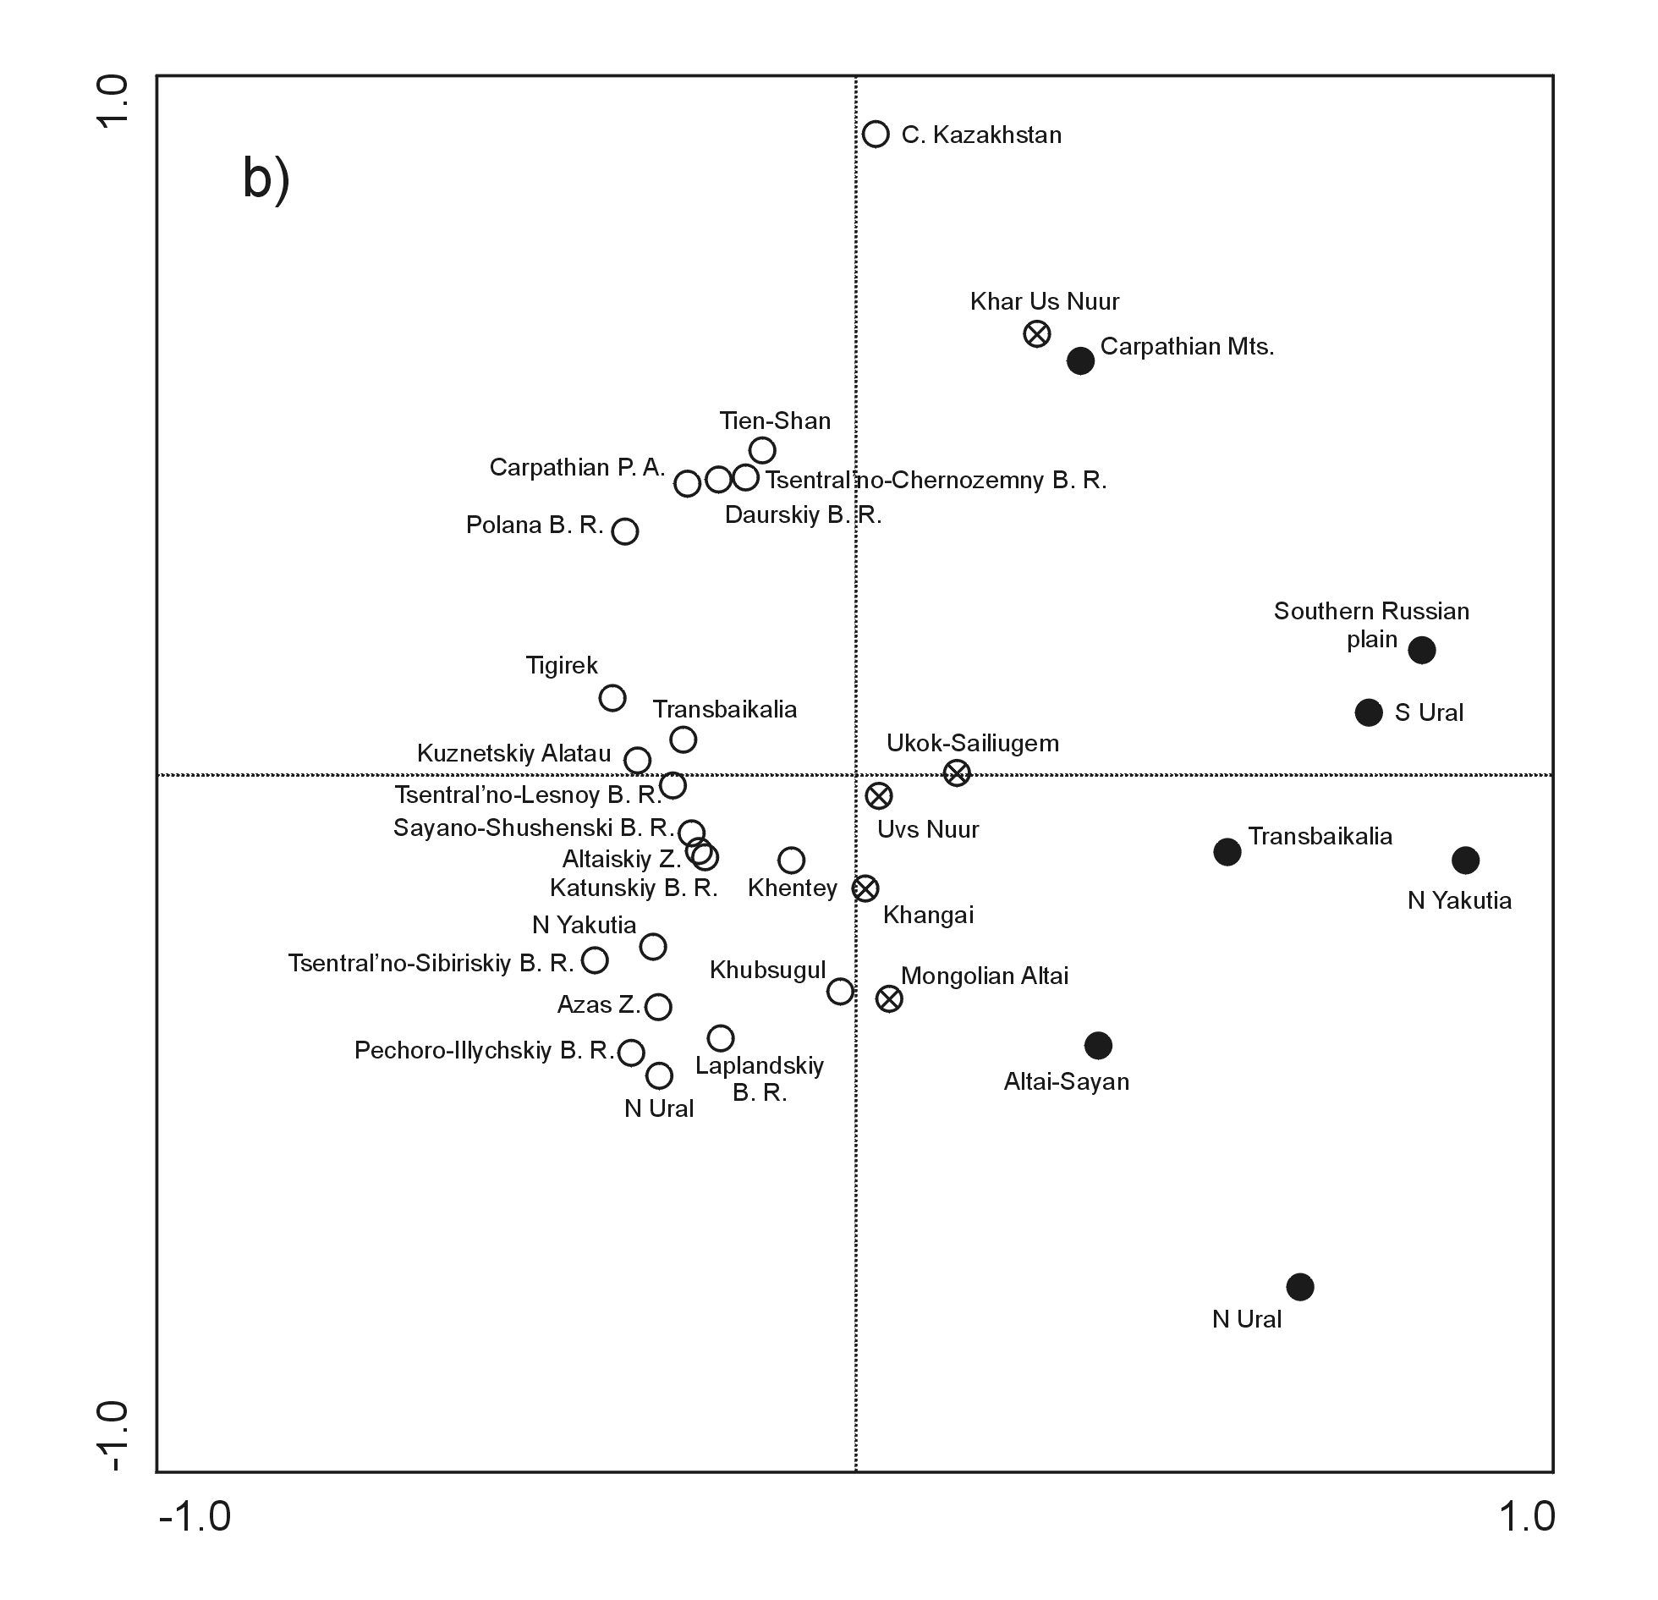

Fig. S3 The projection scores of studied localities according to trophic-size classification (NMDS analysis based on Bray-Curtis dissimilarity indices), a) projection of trophic-sizes, b) projection of localities. Open circles – Recent assemblages; crossed circles – Recent eastern Altai assemblages; full circles – Last Glacial assemblages

