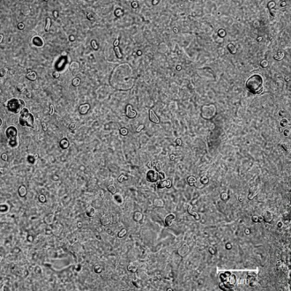
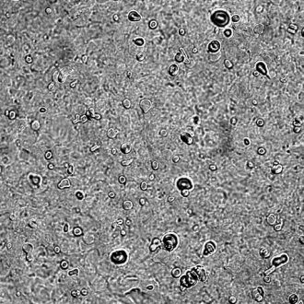
A
B
1 day
5 days

Figure S3. Tracking of LV-GFPFLuc virus in mice with brain inflammation

