Appendix B: Box-and-whisker plots of linear regressions performed on the temporal concentration profiles of 28 metabolites measured for WI and Fresh livers.
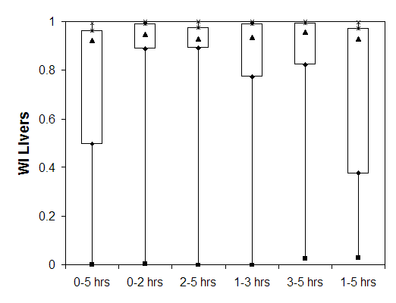
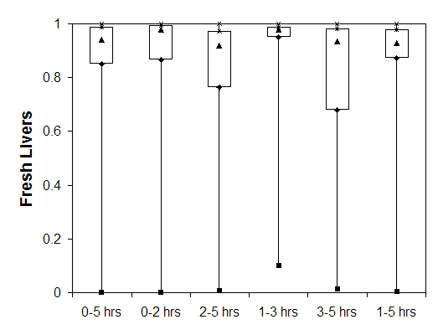
Legend: ■ Minimum. ♦ First quartile. ▲ Median. ∗ Third quartile. × Maximum.

