SUPPORTING INFORMATION

Supporting Text S1. The density and biomass of diurnal, cathemeral, and nocturnal fish species were compared between Palmyra and Tabuaeran using Cohen’s D effect size measurements as:
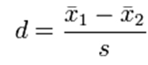
Where:
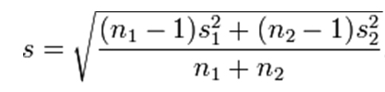

And:
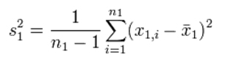

Values from Tabuaeran were set as χ₁ and Palmyra as χ₂ such that positive effect size values represent increases in fish density or biomass at Tabuaeran.

