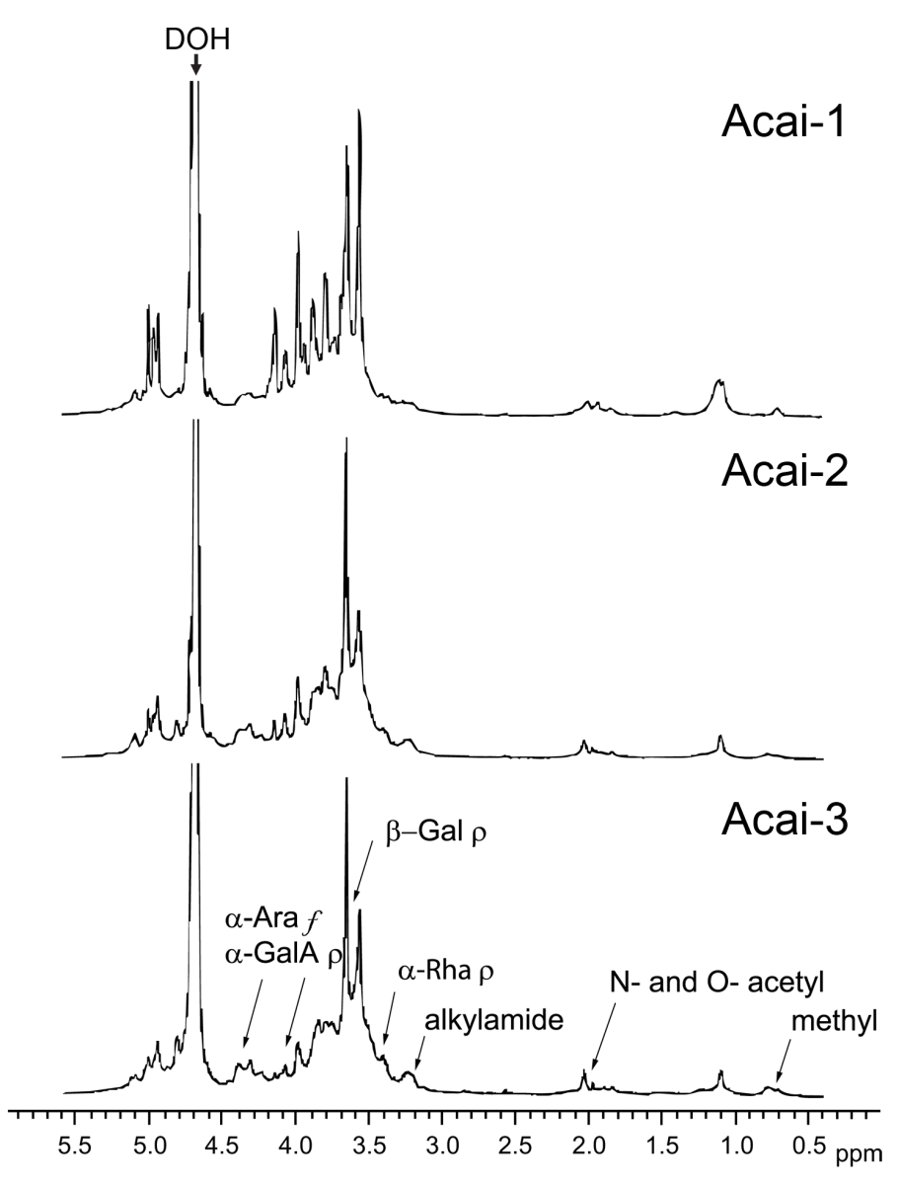
Supplementary Figure 1 ¹H NMR spectra of Acai-PS fractions. The fractions were dissolved in D₂O, and spectra were recorded at 20ºC, as described [41]. Using previously described methods, we predict the following peak associations which are marked on the Acai-3 graph: weak signals present at 3.37-3.45ppm represent α-rhamnopyranose (α-Rha p), the strong signals at 3.54-3.96ppm represent β-galactopyranose (β-Gal p) [81], and the signals at 4.04-5.07ppm represent α-arabinofuranose (α-Ara f) as well as α-galacturonopyranose (α-GalA p) residues [56,81]. N- and O-acetyl (1.9–2.0ppm), methyl (0.75 and 1.1ppm), and alkylamide (3.21ppm) groups are also represented.

