The ARRIVE Guidelines Checklist
Animal Research: Reporting In Vivo Experiments
Carol Kilkenny¹, William J Browne², Innes C Cuthill³, Michael Emerson⁴ and Douglas G Altman⁵
¹The National Centre for the Replacement, Refinement and Reduction of Animals in Research, London, UK, ²School of Veterinary Science, University of Bristol, Bristol, UK, ³School of Biological Sciences, University of Bristol, Bristol, UK, ⁴National Heart and Lung Institute, Imperial College London, UK, ⁵Centre for Statistics in Medicine, University of Oxford, Oxford, UK.

 |  | ITEM | RECOMMENDATION | Section/  Paragraph
 |  |  |  | Title
 |  |  |  | Abstract
 | INTRODUCTION
 | 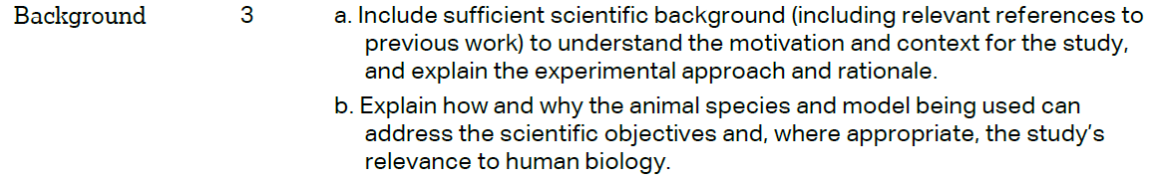 |  |  | Line 37-73  Line 79-91
 |  |  |  | Line 79-91
 | METHODS
 |  |  |  | Line 138-143
 | 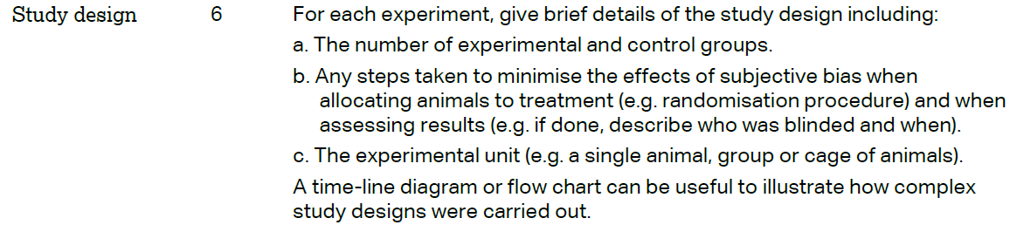 |  |  | Line 129-132  Line 130-134  Line 129-134  Not relevant
 | 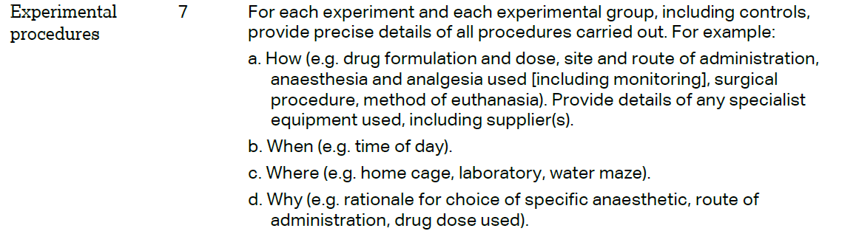 |  |  | Line 152-167; 174-175; 190-193, S3 Table  Line 148-151  Line 149-151  Line 174-175, 190-193
 | 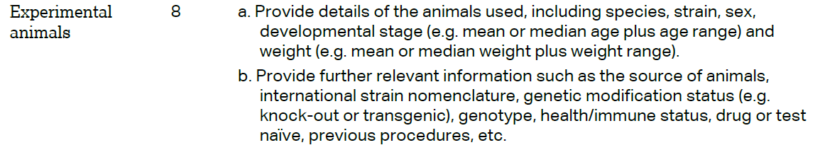 |  |  | Line 129-130  Not relevant
The ARRIVE guidelines. Originally published in PLoS Biology, June 2010¹
 | 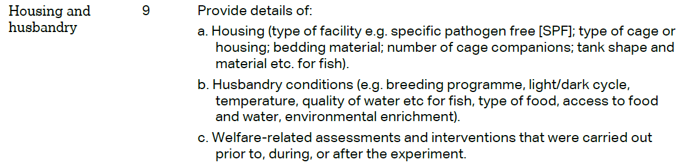 | Line 135-139  Line 135-139  Line 134-135
 | 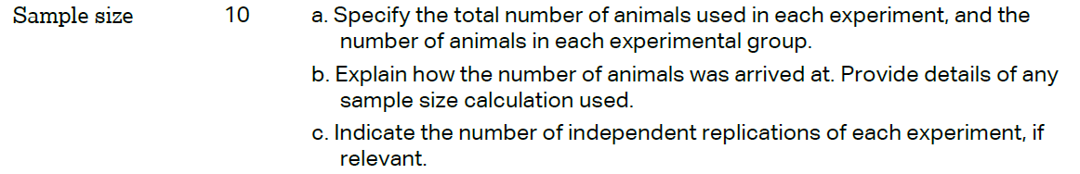 | Line 129, 132  Line 132-134  Not relevant
 | 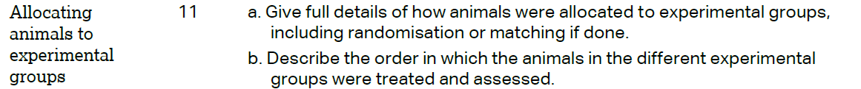 | Line 130-132  Line 149-151, 168-177
 |  | Line180-181
 | 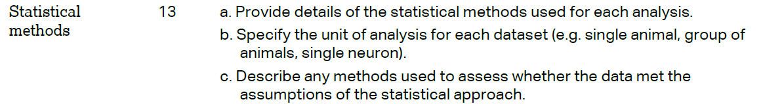 | Line 210-215  Line 214-215  Not relevant
 | RESULTS
 |  | S2 Table
Line 244, 247, 250, 253, 264, 274
Line 280-286
 |  | S2, S3, S5, S6 Tables
Line 277-283
Line 283-286
 | DISCUSSION
 | 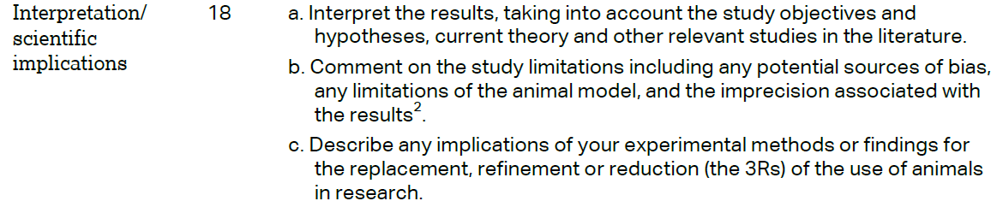 | Line 288-352  Line 353-356  Line 132-134, 174-175
 |  | Line 362-366
 |  | Acknowledgement
