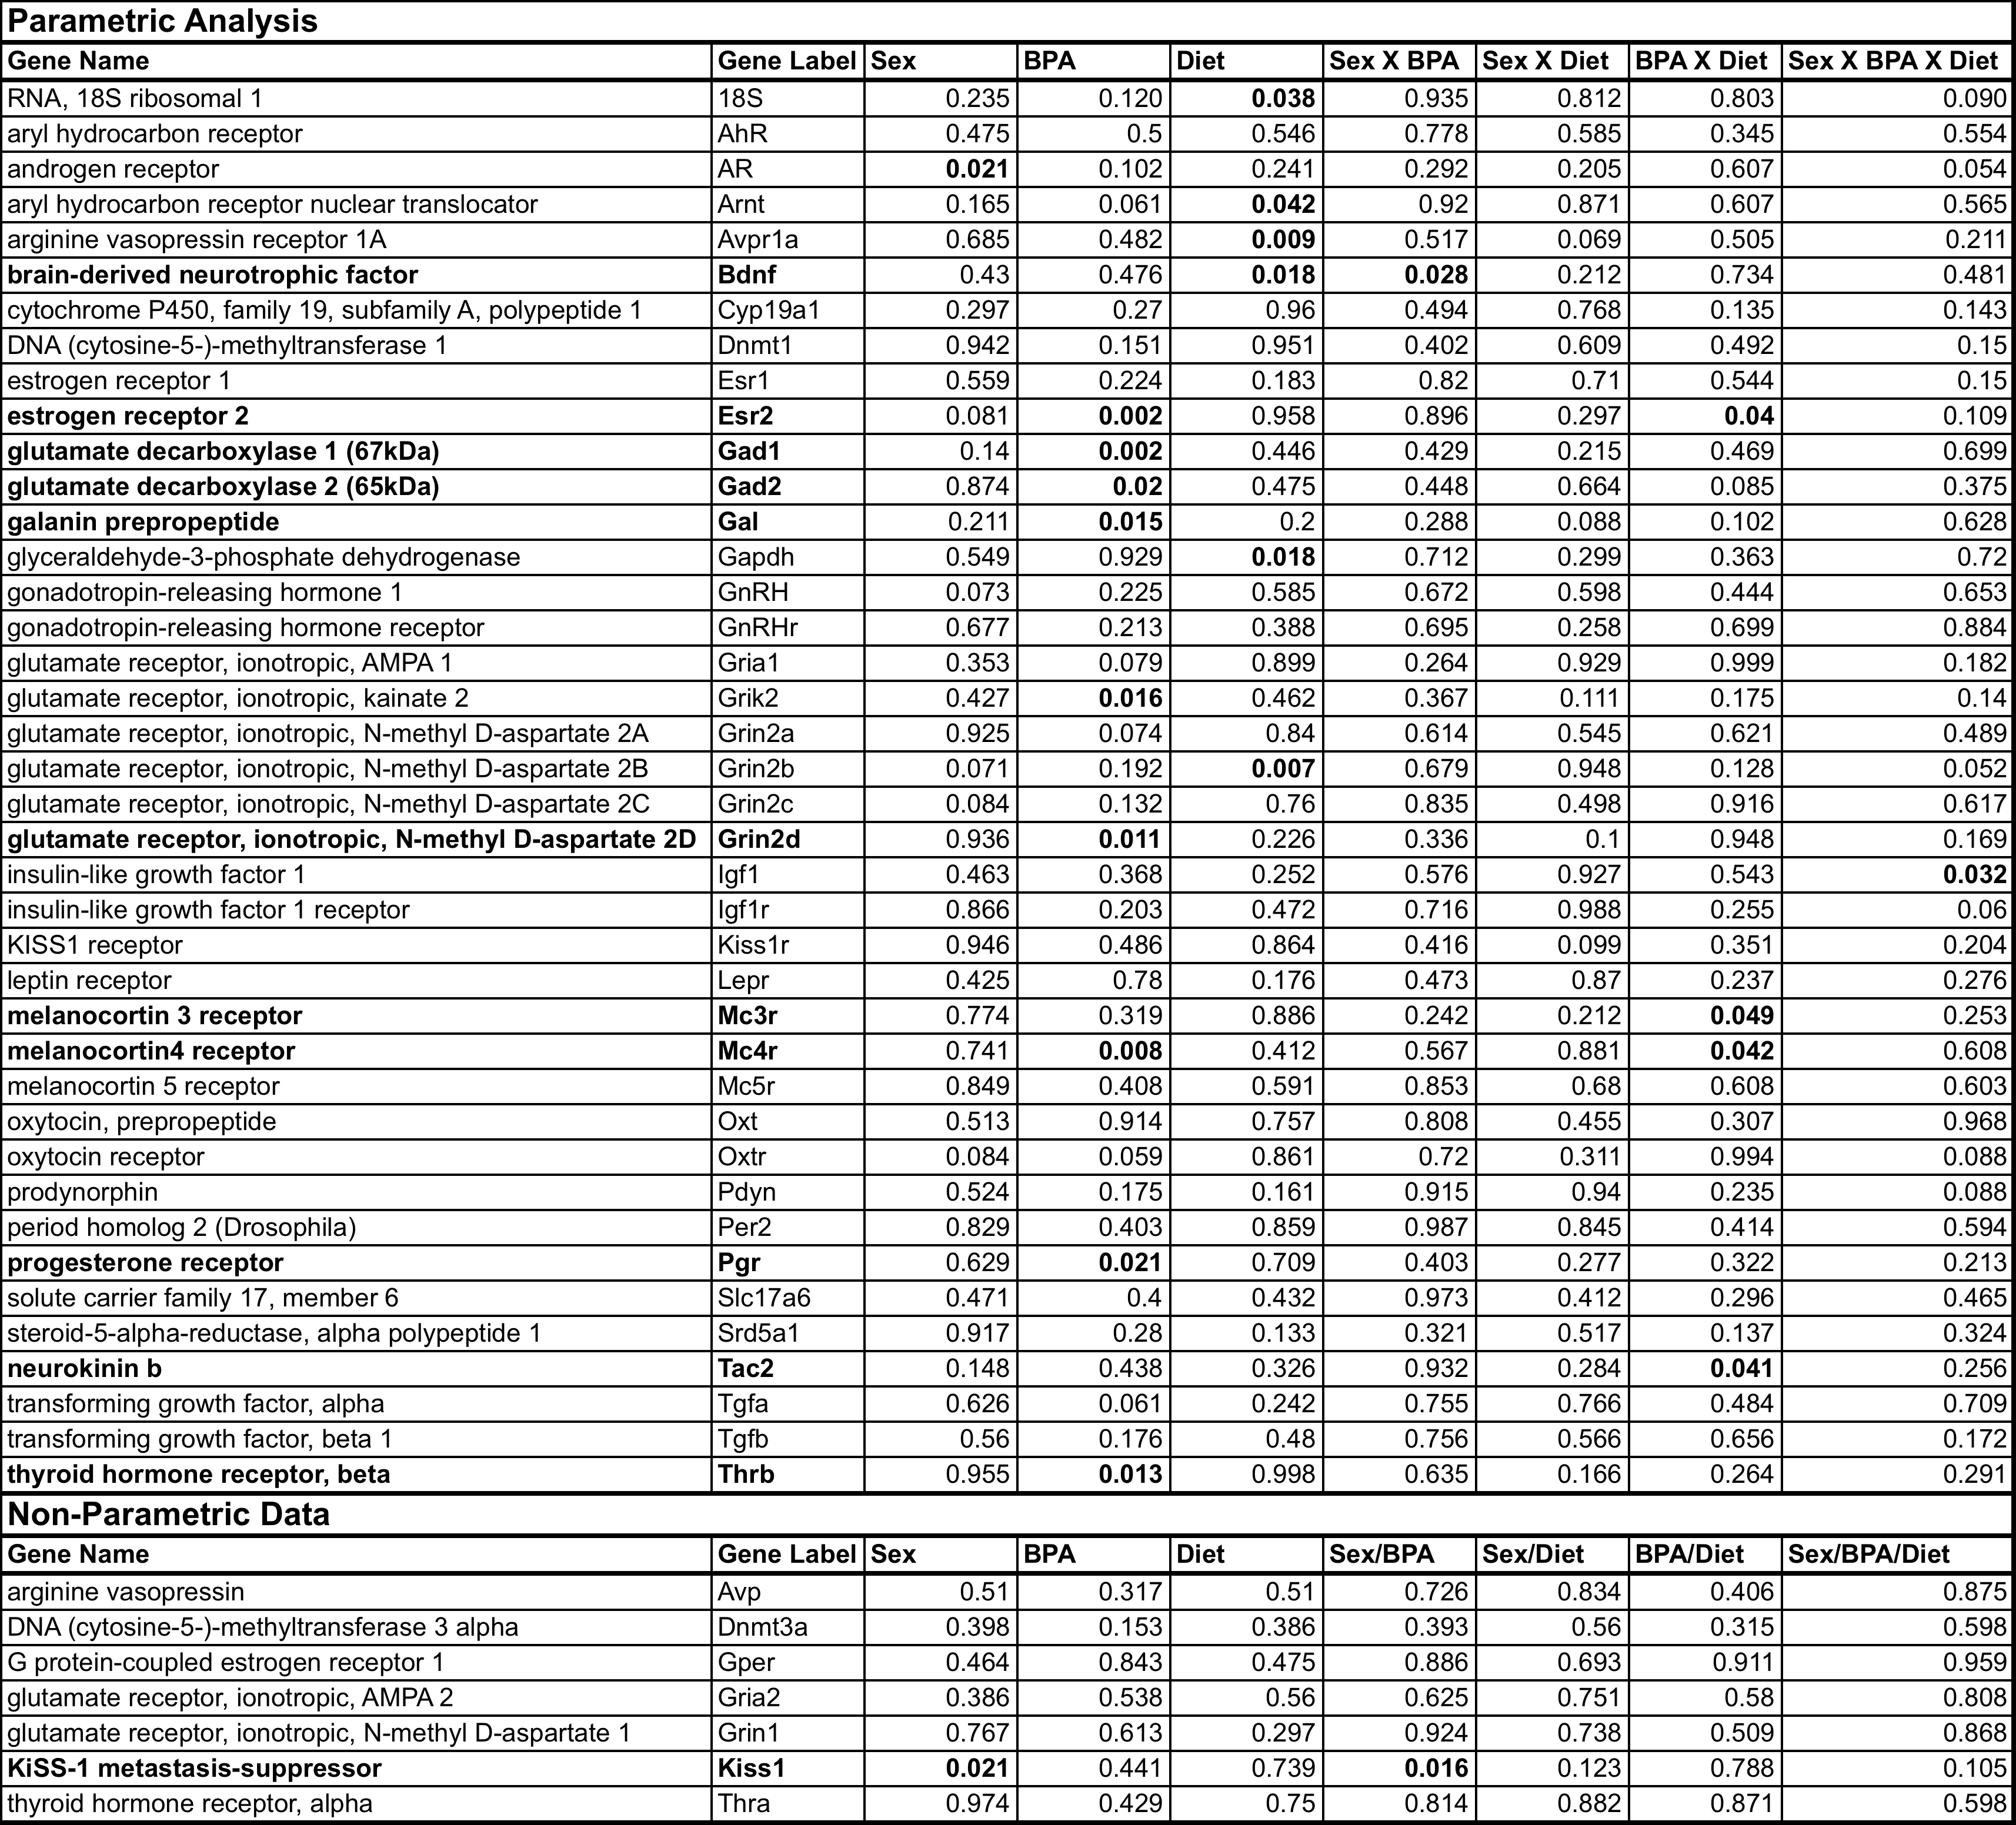
Table S2: List of the 48 genes measured by real-time PCR in the amygdala of male and female rats exposed to BPA, soy diet or BPA and a soy diet

