NAMIBIA
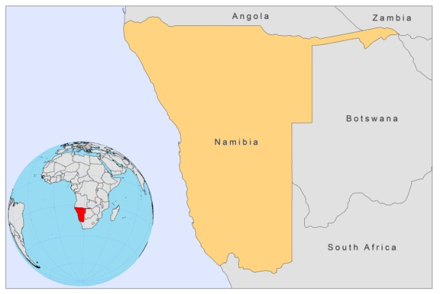

BASIC COUNTRY DATA

Total Population: 2,293,289
Population 0-14 years: 36%
Rural population: 62%
Population living under USD 1.25 a day: no data
Population living under the national poverty line: no data
Income status: Upper middle income economy
Ranking: Medium human development (ranking 120)
Per capita total expenditure on health at average exchange rate (US dollar): 258
Life expectancy at birth (years): 62
Healthy life expectancy at birth (years): 43

BACKGROUND INFORMATION

VL is unknown in Namibia. The first case of CL was described in 1970. Since then, sporadic cases have been reported (34 between 1970 and 1989) from a wide area [1]. The ecology is partly similar to L. aethiopica, but the causative agent is different. It was similar, but not identical, to L. tropica. Its designation is still under discussion [2].

PARASITOLOGICAL INFORMATION

Leishmania species | Clinical form | Vector species | Reservoirs
L. tropica | CL | P. rossi, P. grovei | Procavia capensis

MAPS AND TRENDS, CONTROL, DIAGNOSIS, TREATMENT, ACCESS TO CARE, ACCESS TO DRUGS

No information available.
No antimonials are registered.

SOURCES OF INFORMATION

1. Grové SS (1989). Leishmaniasis in South West Africa Namibia to date. S Afr Med J 75: 290–292.

2. Jacobson RL (2003). Leishmania tropica (Kinetoplastida: Trypanosomatidae) – a perplexing parasite. Folia Parasitologica 50: 241–250.

