Supporting Information

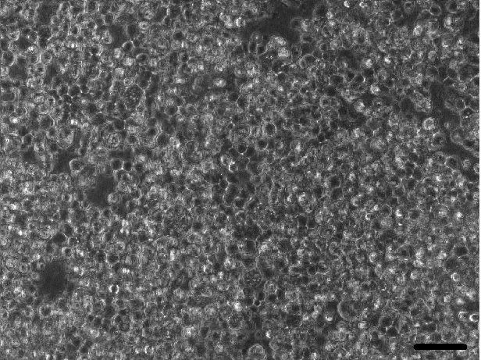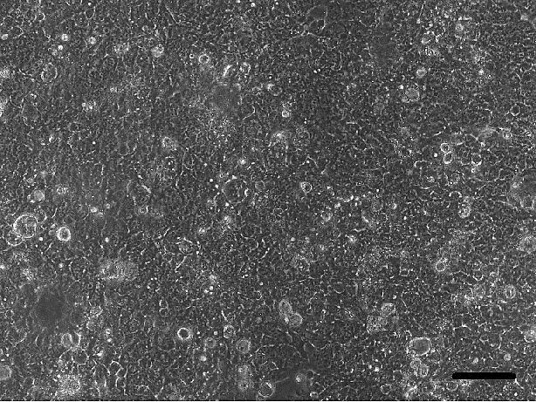
(A)
(B)
S6 Fig. Phase contrast microscopic images of Caco-2 cells seeded in microchambers (A) 2hrs after seeding before starting the continuous flow of DMEM across the cells; (B) 16hr after starting flow of DMEM across the cells. Images were taken at the same position of the same microchamber. (scale bar = 100µm)

