Figure A Part 1 of Questionnaire-demgraphic details

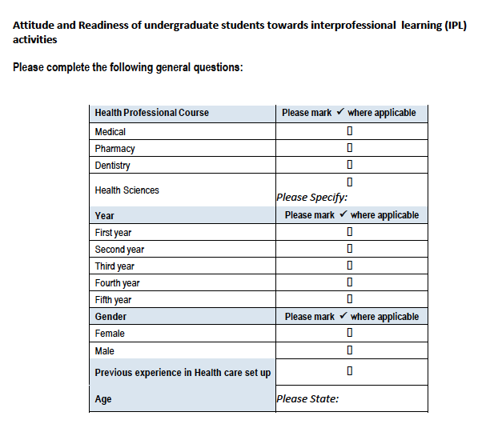

Figure B The Readiness for Interprofessional Learning Scale (RIPLS)
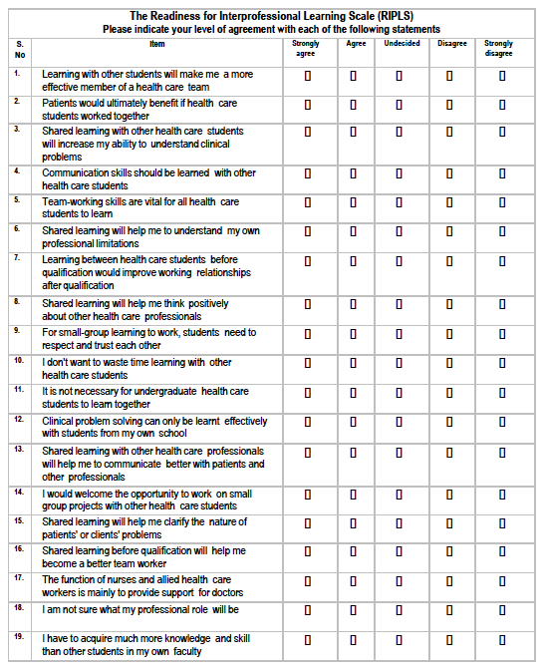

Figure C The Interdisciplinary Education Perception Scale (IEPS)

