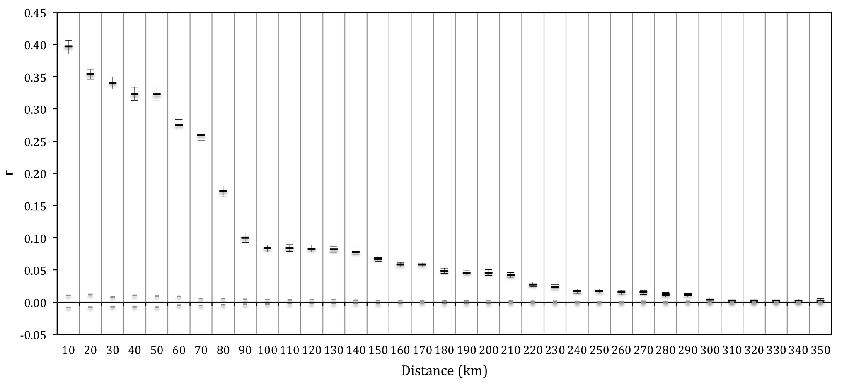
Figure S3. Correlogram showing the autocorrelation coefficient r as a function of increasing distance classes for Central ESU. Distances are the maximum for each class, grey bars indicate 95% CI about the null hypothesis of no genetic structure and error bars about r indicate 95% CI as determined by bootstrapping.

