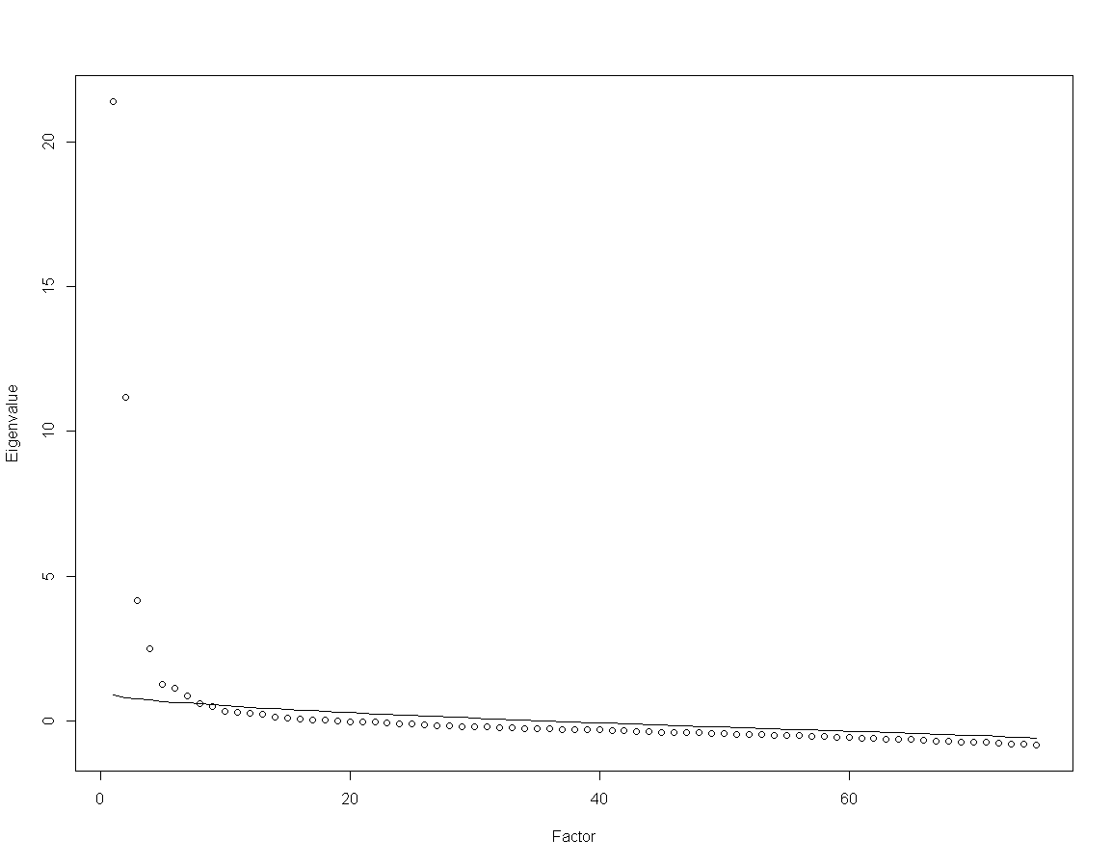
S1 Figure. Eigenvalues of the Items’ Polychoric Correlation Matrix for All 75 Items and the Factor Analytic Model.
Note. The curved line indicates the expected eigenvalues based on a parallel analysis.

