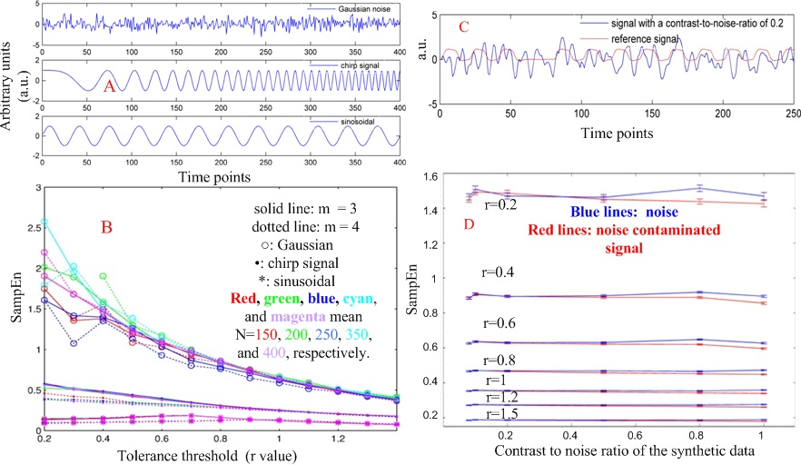
Fig S1. SampEn evaluation results. A) waveforms of a Gaussian noise, a chirp signal, and a sinusoidal signal used for evaluating SampEn; B) SampEn calculation results using different embedded dimensions (m) and different tolerance levels (r) with different data length; C) the hemodynamic response function (HRF)-convolved artificial brain activation (the red line) and noise (the blue line); D) SampEn of noise (blue lines) and noise contaminated brain activation (red lines). The errorbars indicate standard error of SampEn for each calculation.

