Supplementary Figure 1.

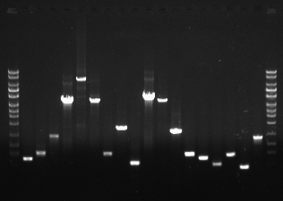
10,000
6,000
4,000
3,000
2,000
1,000
700
500
300
10,000
6,000
4,000
3,000
2,000
1,000
700
500
300
Pair
1
2
3
4
5
6
7
8
9
10
11
12
13
14
15
16
17
18

Supplementary Figure 1. PCR verification of contig order and orientation in assembly of T. aquaticus genome. A 1.7% agarose gel stained with ethidium bromide was electrophoresed at 130 V for 45 min. The DNA size ladder is Lucigen’s GelReady 1 kb. Lane labels in figure correspond directly to the Pair # column in Table 1, such that Pair 1 refers to the pair of Primers 2 and 3, Pair 2 refers to the pair of Primers 4 and 5, and so on.

