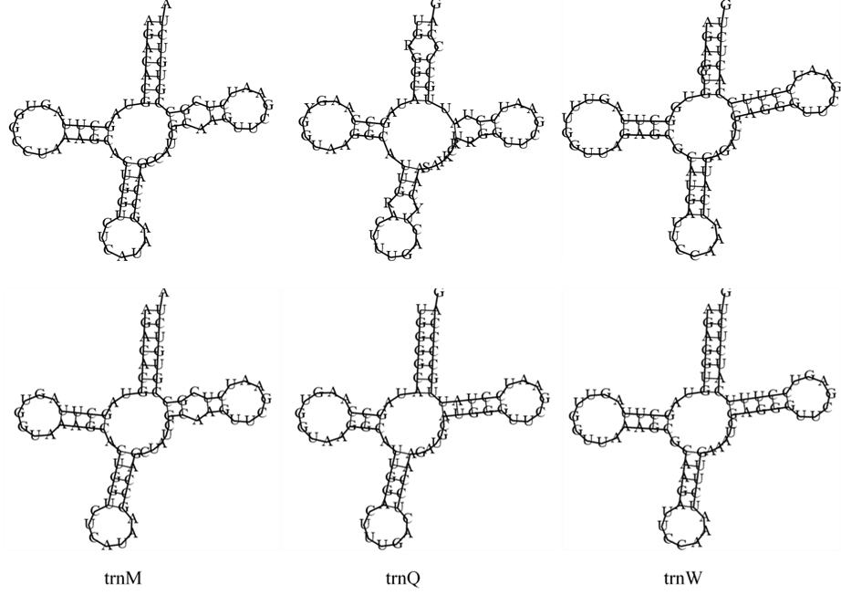
S1 fig. Secondary structure of tRNA present in mtDNA of Chlamydomonas biconvexa Embrapa|LBA40 (upper) and Chlamydomonas reinhardtii (lower).

