S6 Text. Sensitivity analysis of $f_{rec}$ and $A_{N}$ to $t_{cyt,in}$ and $t_{cyt,out}$

In the main text, it is assumed that $t_{cyt,in}=t_{cyt,out}=t_{cyt}$ and that the thickness of the cytosol compartments equals the ones measured from TEM images. Mitochondria compartments were not modelled explicitly, because this would increase the computational time considerably and because the dimensions of mitochondria are very uncertain. It was not possible to systematically measure the thickness from the TEM images in [1], because the mitochondria were often hard to distinguish from the cytosol or from other organelles. As far as the authors know, there have been no previous studies that systematically measured the dimensions of mitochondria in mesophyll cells. Some sample images from a number of studies [2-4] suggest that these dimensions can vary considerably. In some cases, the thickness reported is larger than the assumed cytosol thicknesses in this study. In this section, a sensitivity analysis will be done for $t_{cyt,in}$ and $t_{cyt,out}$ to assess how uncertainty in the thickness of the inner and the outer cytosol could affect the net CO₂ assimilation rate and the re-assimilation of (photo)respired CO₂.

S6.1 Re-parameterization of the geometry
In order to conduct sensitivity analyses for $t_{cyt,in}$ and $t_{cyt,out}$ separately, it can no longer be assumed that $t_{cyt,in}=t_{cyt,out}=t_{cyt}$. This has implications for all parameterized ratios in Table 3 in the main text that depend on the cytosol thickness. First, $t_{cyt,inner}$ was substituted for $t_{cyt}$ in the mathematical term for the ratio $S/V_{cyt,inner}$. Second, substituted $t_{cyt,out}$ was substituted for $t_{cyt}$ in the term for the ratio $S/V_{cyt,out}$. Table A in S3 shows the updated mathematical terms for all volume to volume, length to volume and surface to volume ratios.

S6.2 Sensitivity analysis of $A_{N}$ and $f_{rec}$ to $t_{cyt,in}$ and $t_{cyt,out}$
For this analysis, the net CO₂ assimilation rate under ambient CO₂ and O₂ levels and saturating light levels was simulated for two scenarios. (Photo)respiratory CO₂ release takes either place in the inner or in the outer cytosol. During this analysis, the cytosol thicknesses (either $t_{cyt,inner}$ or $t_{cyt,outer}$) were varied between 50 nm and 500 nm with steps of 50 nm. Fig A shows these simulated values of A_{N}. Additionally, a sensitivity analysis of $f_{rec}$ was done under ambient CO₂ ($C_{a}=40 Pa$) and saturating light ($I_{inc}=1500 μmol m^{-2} s^{-1}$) by varying either $t_{cyt,in}$ or $t_{cyt,out}$. Fig B shows the result of this analysis. $f_{rec}$ and $A_{N}$ hardly change with an increase in $t_{cyt,inner}$ for both scenarions for the localization of (photo)respired CO₂ release (Fig A Panel A and Fig B Panel A). The change of $f_{rec}$ and $A_{N}$ with $t_{cyt,outer}$ is somewhat larger for both scenarios, but the change is still rather small.

A | B
Fig A: Simulated values of the net CO₂ assimilation rate for different inner cytosol and outer cytosol thicknesses, under the condition of ambient CO₂ ($C_{a}$ = 40 Pa) and O₂ ($O$ = 21 kPa) and saturating light levels ($I_{inc}$ = 1500 μmol m⁻² s⁻¹). The solid lines represent simulations assuming that (photo)respiratory CO₂ is released in the inner cytosol. The dashed lines are simulations which assume (photo)respiratory CO₂ release in the outer cytosol.

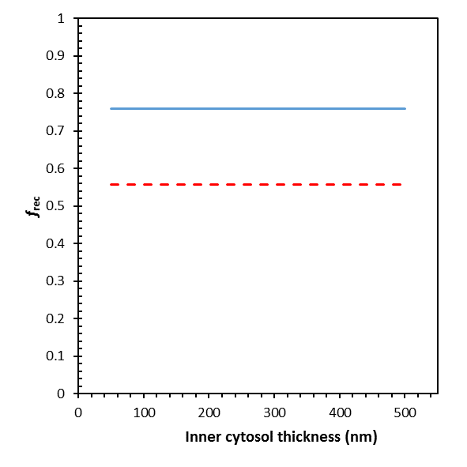  A | 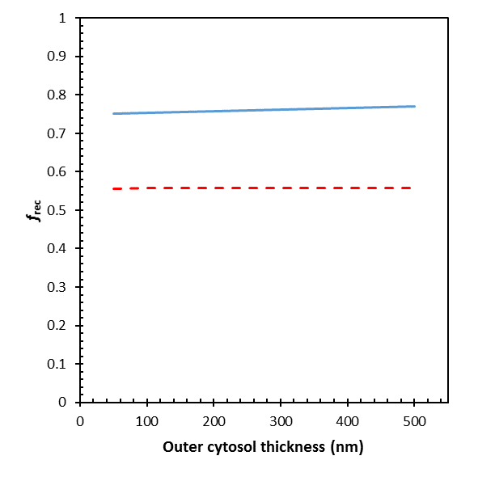  B
Fig B: Simulated values of $f_{rec}$ for different inner cytosol and outer cytosol thicknesses, under the condition of ambient CO₂ ($C_{a}$ = 40 Pa) and O₂ ($O$ = 21 kPa) and saturating light levels ($I_{inc}$ = 1500 μmol m⁻² s⁻¹). The solid lines represent simulations assuming that (photo)respiratory CO₂ is released in the inner cytosol. The dashed lines are simulations which assume (photo)respiratory CO₂ release in the outer cytosol.

References
1. Berghuijs HNC, Yin X, Ho QT, Van der Putten PEL, Retta MA, et al. (2015) Modeling the relationship between CO₂ assimilation and leaf anatomical properties in tomato leaves. Plant Science 238: 297-311.
2. Busch FA, Sage TL, Cousins AB, Sage RF (2013) C₃ plants enhance rates of photosynthesis by reassimilating photorespired and respired CO₂. Plant Cell and Environment 36: 200-212.
3. Gielwanowska I, Pastorczyk M, Kellmann-Sopyla W, Gorniak D, Gorecki RJ (2015) Morphological and ultrastructural changes of organelles in leaf mesophyll cells of the Arctic and Antarctic plants of Poaceae family under cold influence. Arctic Antarctic and Alpine Research 47: 17-25.
4. Moser T, Holzinger A, Buchner O (2015) Chloroplast protrusions in leaves of Ranunculus glacialisL. respond significantly to different ambient conditions, but are not related to temperature stress. Plant Cell and Environment 38: 1347-1356.

