A
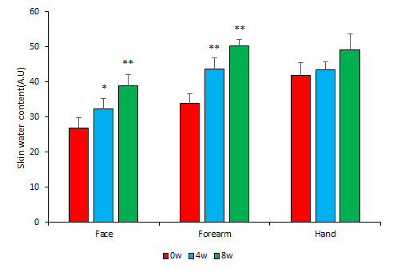
B
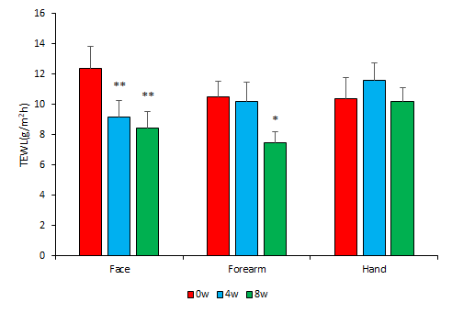
S1 Fig. Changes of skin condition after 8 wk of HY7714 consumption.
Changes in skin water content (A) and transepidermal water loss (B) measured at three areas (face, forearm, and hand) every 4 wk for 8 wk. Data are analyzed using the Wilcoxon signed-rank test. Results are expressed as Mean ± SEM. Asterisks (* and **) indicate a significant difference (p < 0.05 and p < 0.01, respectively) compared to the baseline.

