S2 Appendix. Semi-structured interview: Results of standardised questionnaires.

Perceived user experience and usability (UMUX)
Subject | % UMUX Overall Score | % Adjusted Formula
1 | 40.91 | 49.49
2 | 45.45 | 52.45
3 | 27.27 | 40.63
4 | 36.36 | 46.54
5 | 40.91 | 49.49
6 | 40.91 | 49.49
7 | 54.55 | 58.35
8 | 50.00 | 55.40
9 | 36.36 | 46.54
10 | 45.45 | 52.45
11 | 36.36 | 46.54
12 | 13.64 | 31.76
13 | 36.36 | 46.54
14 | 54.55 | 58.35
15 | 36.36 | 46.54
16 | 40.91 | 49.49
17 | 31.82 | 43.58
18 | 22.73 | 37.67
19 | 22.73 | 37.67
Total | 37.56 | 47.31
Grading scale |  | Grade F
Standard deviation | 10.41 | 6.77
Cronbach’s Alpha | 0.68

Acceptance (TAM)

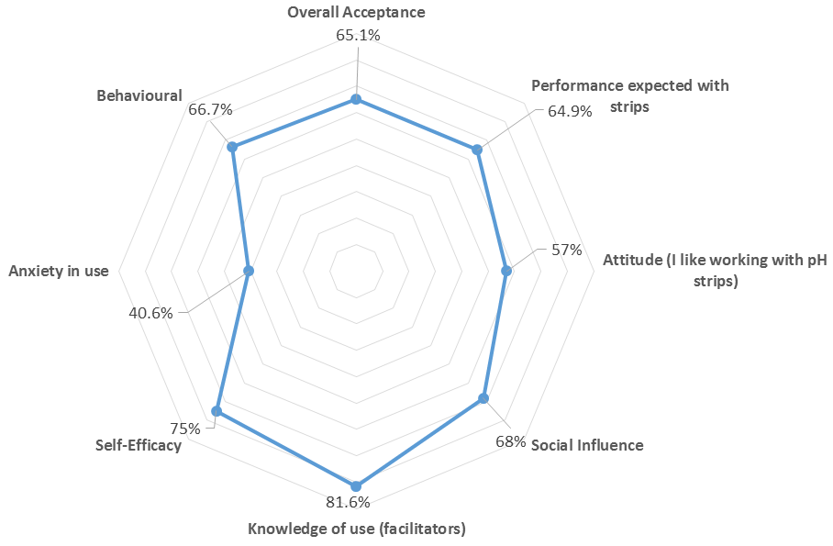
Acceptance Factors  Items from 1 to 13 - Appendix 2B | Score (%) | Standard deviation
Performance expected with strips | 64.9 | 20.4
Attitude (I like working with pH strips) | 57 | 27.3
Social Influence | 68 | 23.5
Knowledge of use (facilitators) | 81.6 | 14.1
Self-Efficacy | 75 | 17.4
Anxiety in use | 40.6 | 29.9
Behavioural | 66.7 | 28.5
Overall Acceptance | 65.1 | 14.2
Availability of correct pH strips in the clinical field  Item14 - Appendix 2B | 47.4 | 38

Professional trust (TIU)

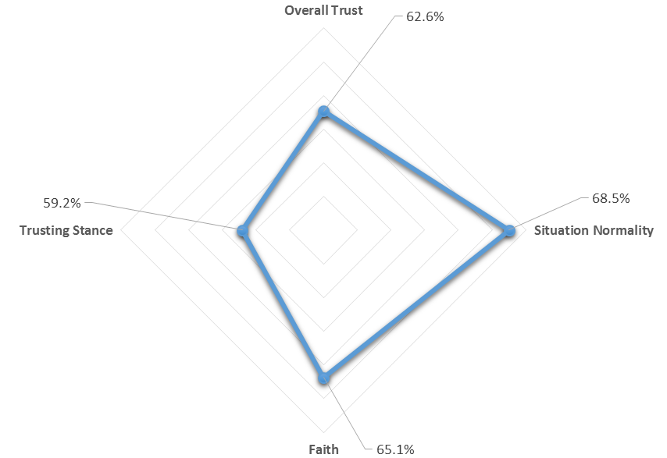

Trust factors  Items from 1 to 9 - Appendix 2B | Score (%) | Standard deviation
Situation Normality | 68.5 | 16.1
Faith | 65.1 | 18.8
Trusting Stance | 59.2 | 18.1
Overall Trust | 62.6 | 13.9
Use of alternative methods  Item 10 - Appendix 2B | 62 | 33.4

