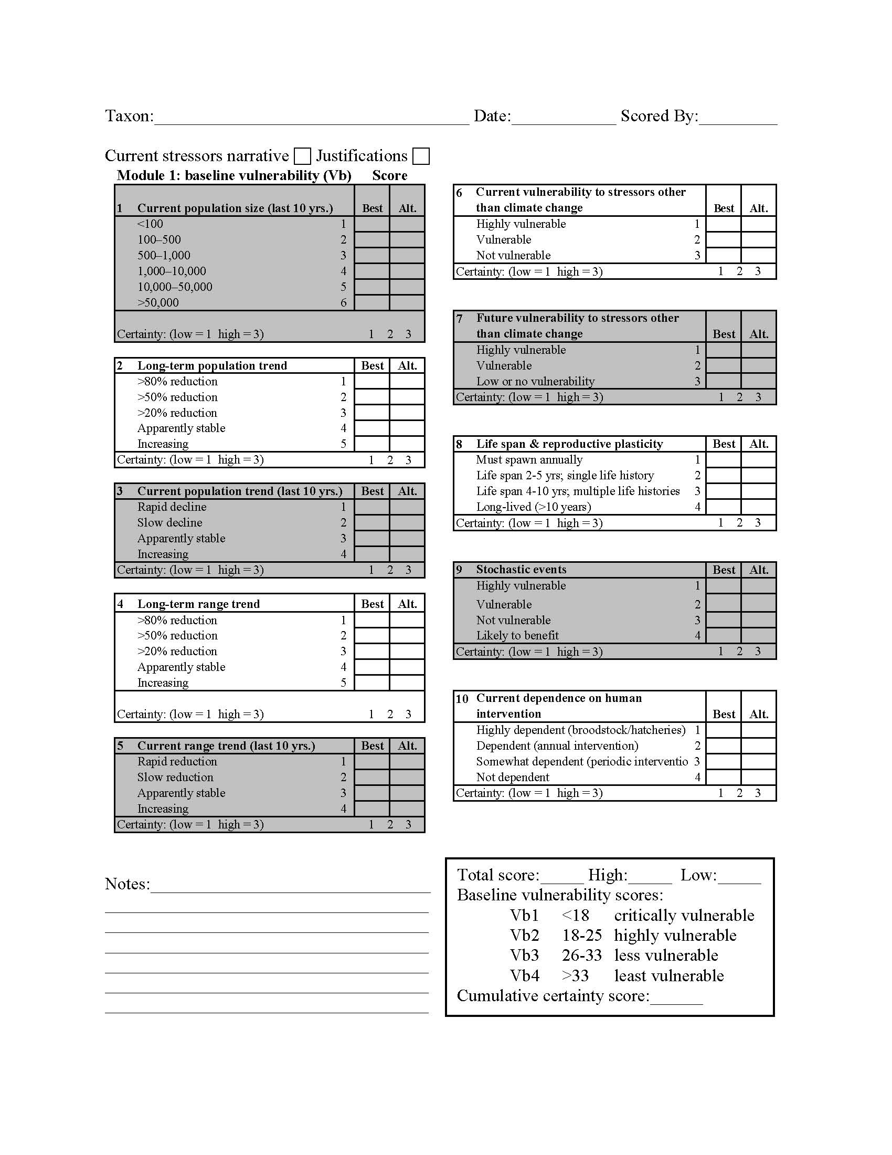
Data sheet S1. Module 1 score sheet for determining baseline vulnerability of California fishes. Table S1.Baseline and climate change vulnerability scores for native and alien fishes in California, as determined by methods discussed in this paper.

