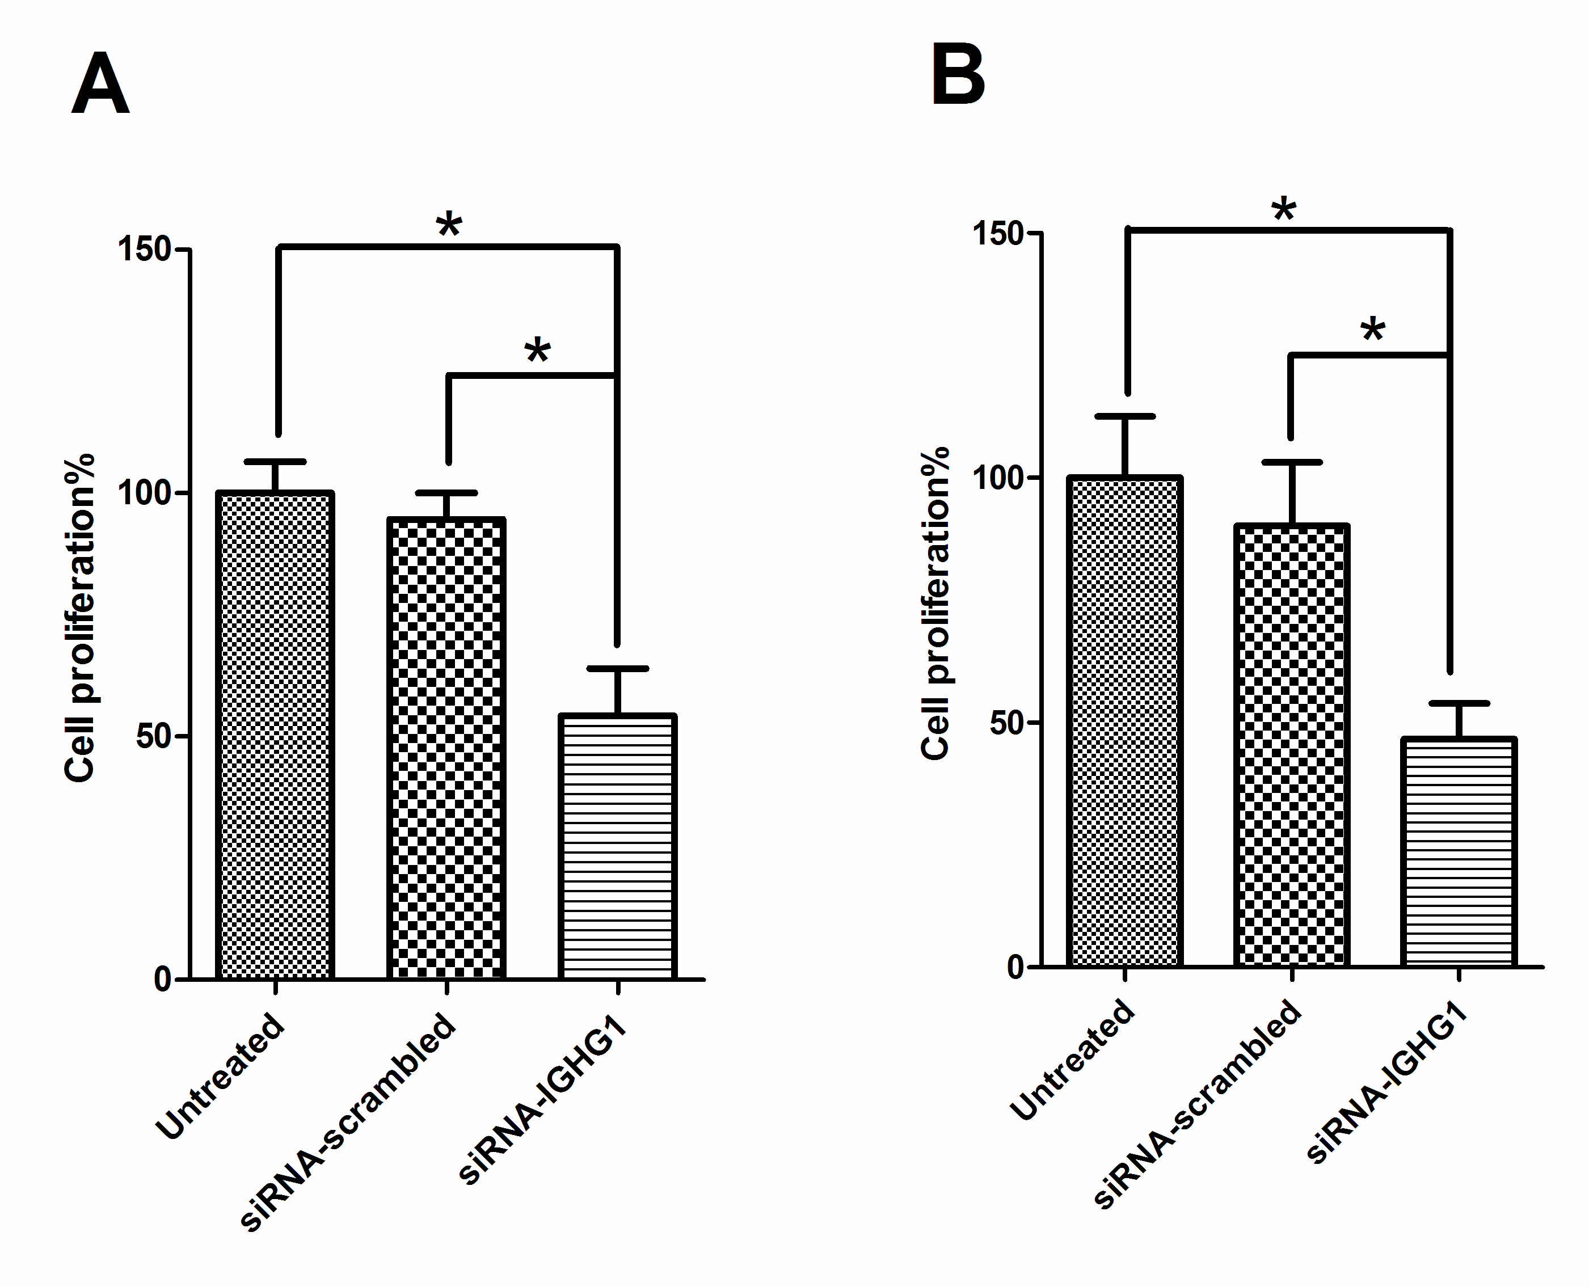
Figure S1. IGHG1 siRNA induced reduction of IgG expression inhibited lung cancer cell proliferation. A, A549 cell line. B, SK-MES-1 cell line. The histograms represent the three independent assays. Data are presented as mean ± S.E. *, p < 0.05.

