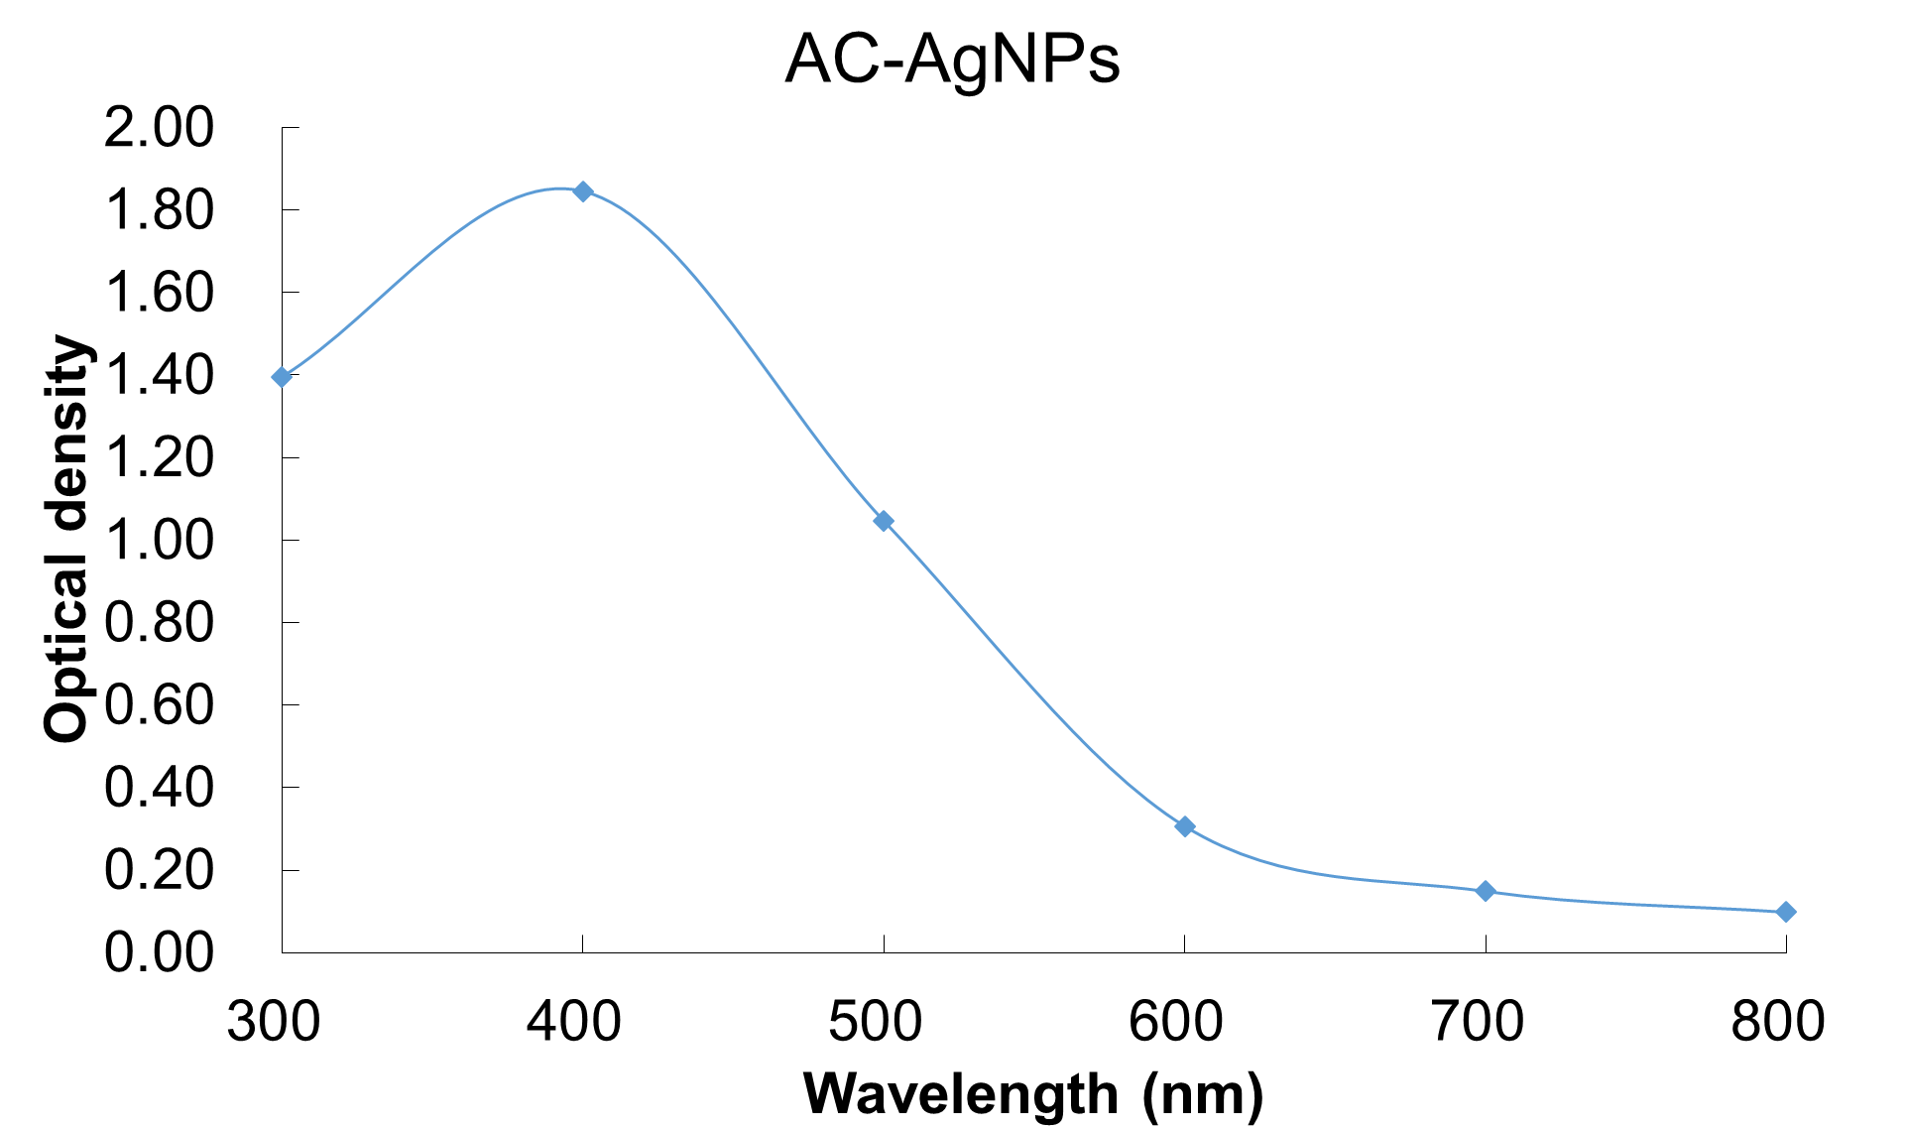
S1 Fig: Optical density of AgNPs suspended in DMEM before the treatment to HepG2 cell.

