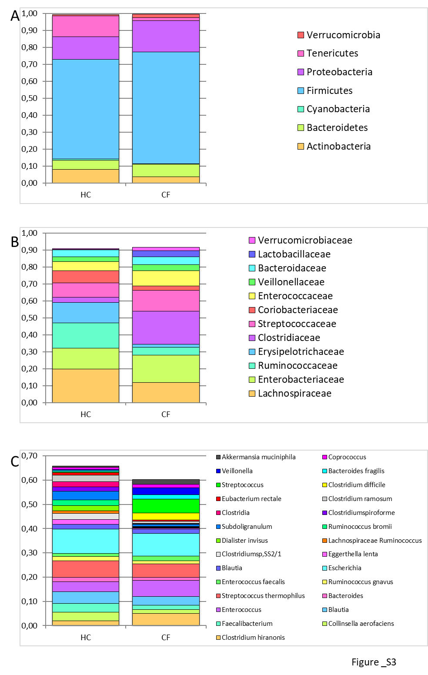

S2 Fig.
Legend. Bar chart representing the OTU relative abundances in HC and CF at phylum (Panel A), family (Panel B) and species (Panel C) levels. The OTUs reported in the bar charts have been selected for relative abundance >0.01.

