S1 Figure. Global ancestry proportions plot of GDM and SIGMA samples, as well as parental samples from The Human Genome Diversity Project (HGDP) and The Mexican Genome Diversity Project (MGDP).

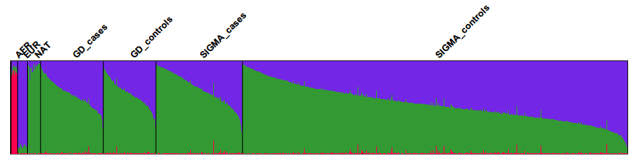

Native American ancestry proportion (%)
 | Controls | Cases | P value
GDM | 65.42 [56.12-73.82] | 63.38 [54.29-74.08] | 0.3004
SIGMA T2D | 51.83 [39.67-66.35] | 70.86 [57.58-84.86] | 1.02x10⁻⁷³
*It is shown median [25th percentile-75th percentile].

