S1 Fig. Network structures used in simulation section (generated by geneNetWeaver [1] ). a) size 10 b) size 50 c,d) size 100
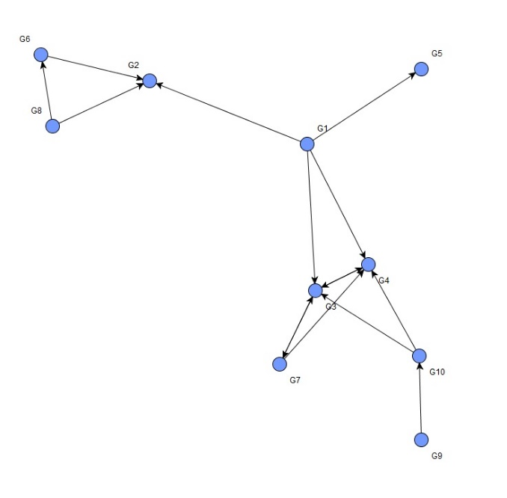
(a)
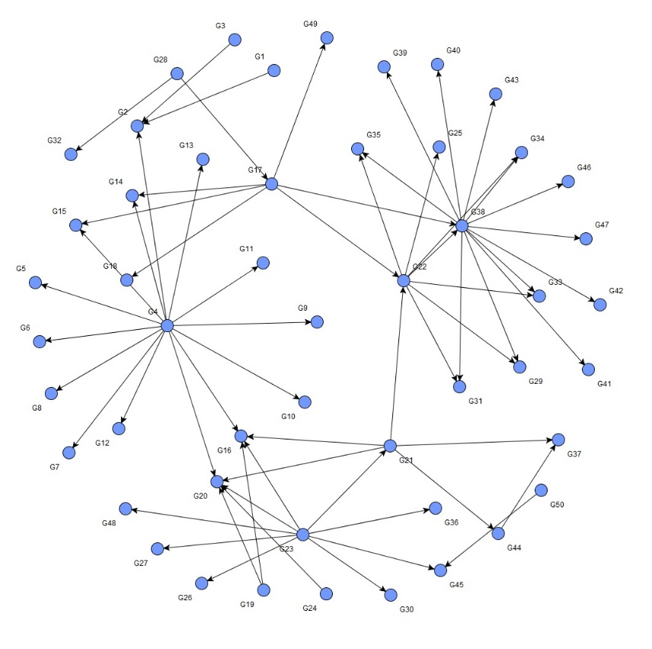
(b)
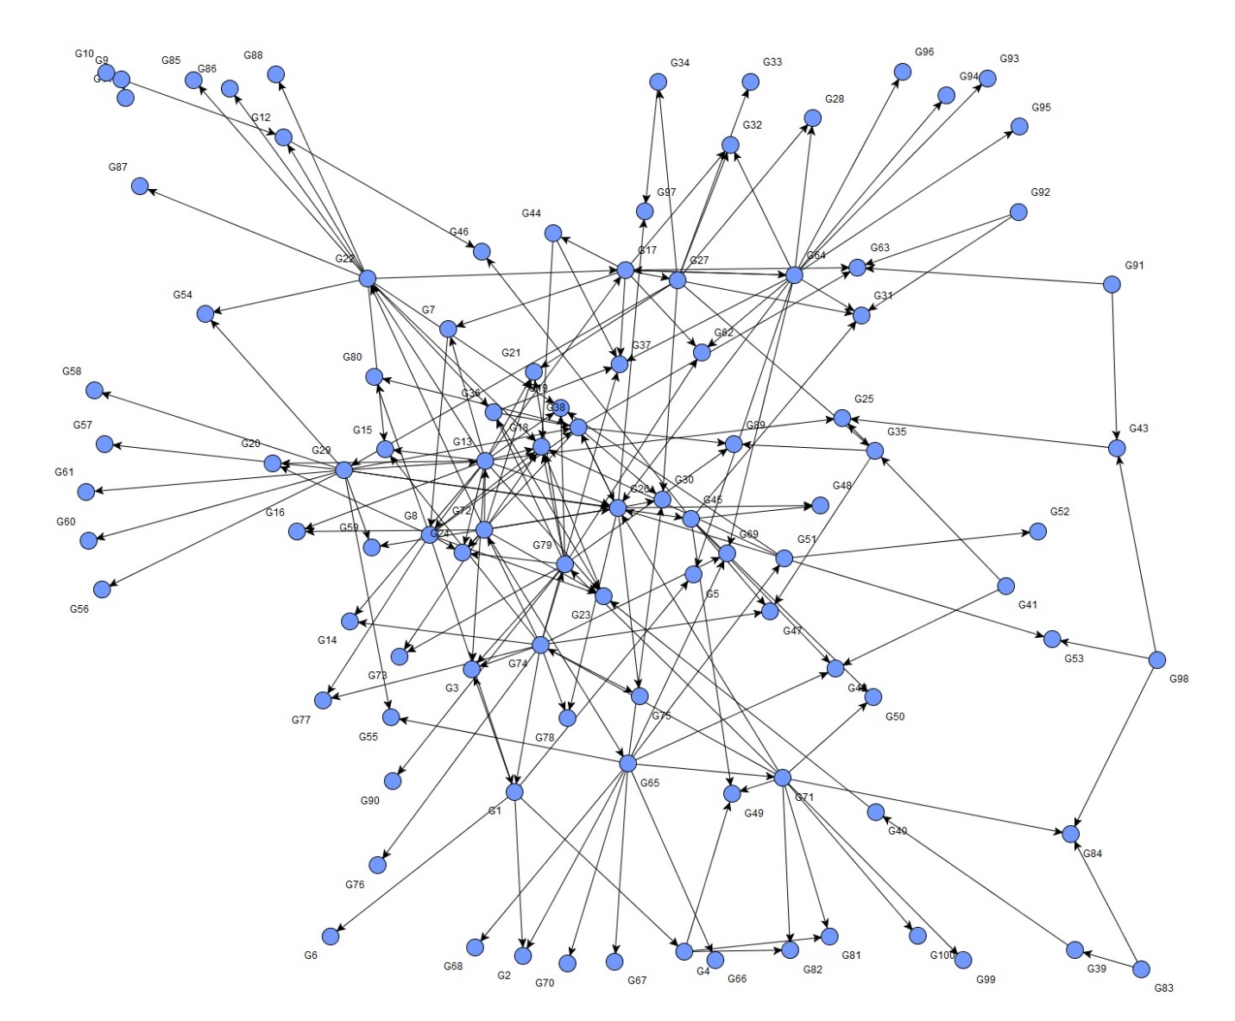
(c)

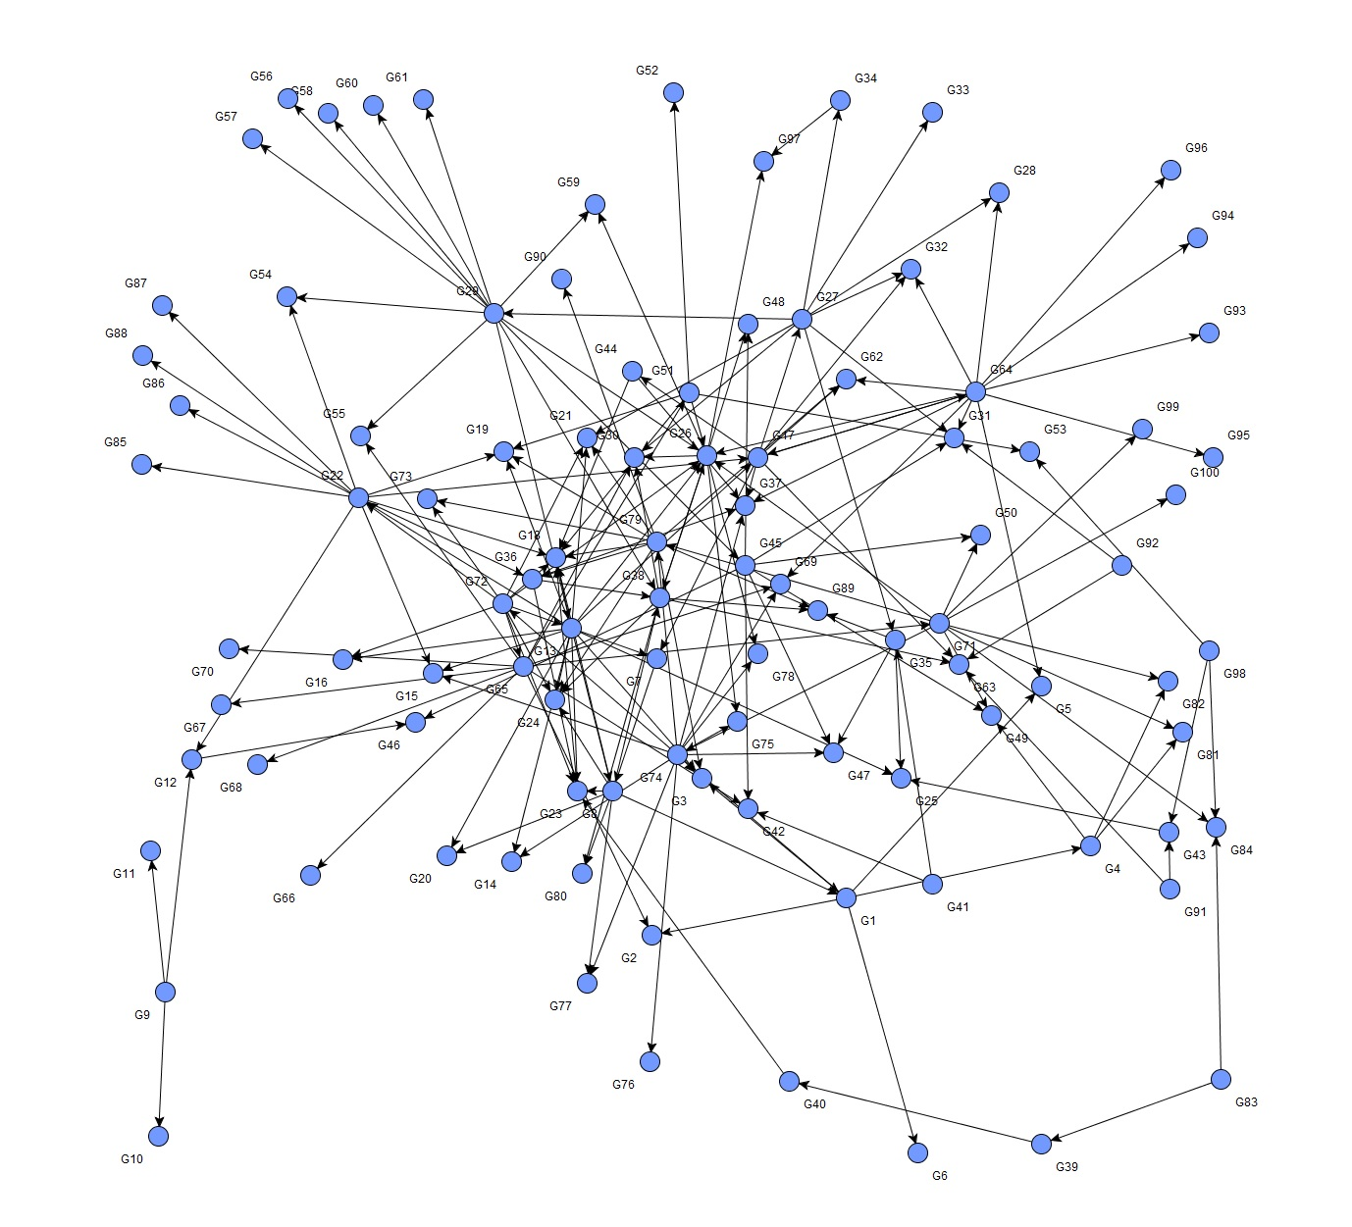
(d)

References
1. Schaffter, T., D. Marbach, and D. Floreano, GeneNetWeaver: in silico benchmark generation and performance profiling of network inference methods. Bioinformatics, 2011. 27(16): p. 2263-2270.

