A
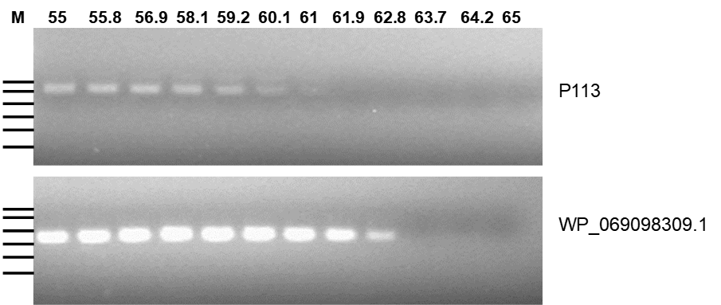

B
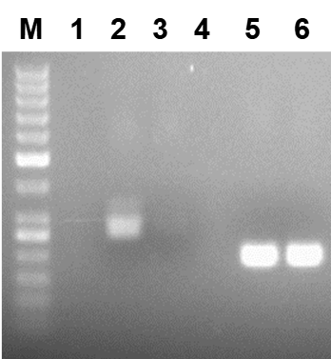
S1 Fig. Comparison of PCR-based detection of p113 and WP_069098309.1 gene target. A; Gradient PCR of P113 and WP_069098309.1 gene targets. Standard PCR was performed using 10⁴ copies of standard DNA_P113 and standard DNA_WP_069098309.1 with specific primers annealed at temperature gradient of 55, 55.8, 56.9, 58.1, 59.2, 60.1, 61, 61.9, 62.8, 63.7, 64.2 and 65°C, B; Standard PCR of P113 and WP_069098309.1 gene targets. Standard PCR was performed using 10 ng of purified genomic DNA from M. ovipneumoniae with specific primers annealed at 55°C and 60°C. Lane; M represents 50-base pair molecular weight ladder, 1; Empty, 2; P113 at 55°C, 3; P113 at 60°C, 4; Empty, 5; WP_069098309.1 at 55°C, 6; WP_069098309.1 at 60°C. The amplification was performed for 40 cycles and after completion, amplicons were separated by agarose gel electrophoresis.

