MAURITANIA

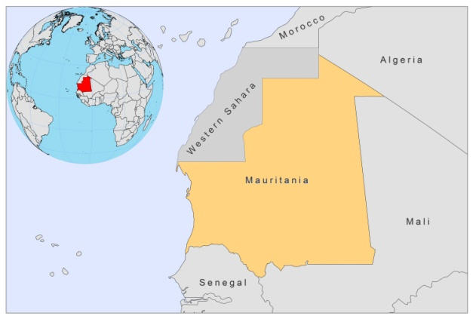

BASIC COUNTRY DATA

Total Population: 3,459,773
Population 0-14 years: 40%
Rural population: 59%
Population living under USD 1.25 a day: 21.2%
Population living under the national poverty line: no data
Income status: Lower middle income economy
Ranking: Low human development (ranking 159)
Per capita total expenditure on health at average exchange rate (US dollar): 22
Life expectancy at birth (years): 58
Healthy life expectancy at birth (years): 45

BACKGROUND INFORMATION

Leishmaniasis is rare in Mauritania. VL is unknown and only sporadic cases of CL have been reported. These originated from Aloun-el-Atrouss, the Nema region and near the borders with Senegal and Mali [1]. As Mauritania is part of a proposed CL endemicity belt, running across West Africa, more cases may occur than are officially reported.

PARASITOLOGICAL INFORMATION

Leishmania species | Clinical form | Vector species | Reservoirs
L. major | CL | P. duboscqi,  P. bergeroti | Unknown
L. infantum | VL, CL | Unknown | Unknown

MAPS AND TRENDS

No information available.

CONTROL

Notification of leishmaniasis is mandatory.

DIAGNOSIS, TREATMENT, ACCESS TO CARE

No information available.

ACCESS TO DRUGS

No antimonials are registered.

SOURCES OF INFORMATION

1. Desjeux P (1991) Information on the epidemiology and control of the leishmaniases by country or territory. World Health Organization. WHO/LEISH/91.30.

