SUPPORTING FIGURE S3 for

Discerning the Subfribillar Structure of Mineralized Collagen Fibrils: a Model for the Ultrastructure of Bone

Yuping Li and Conrado Aparicio

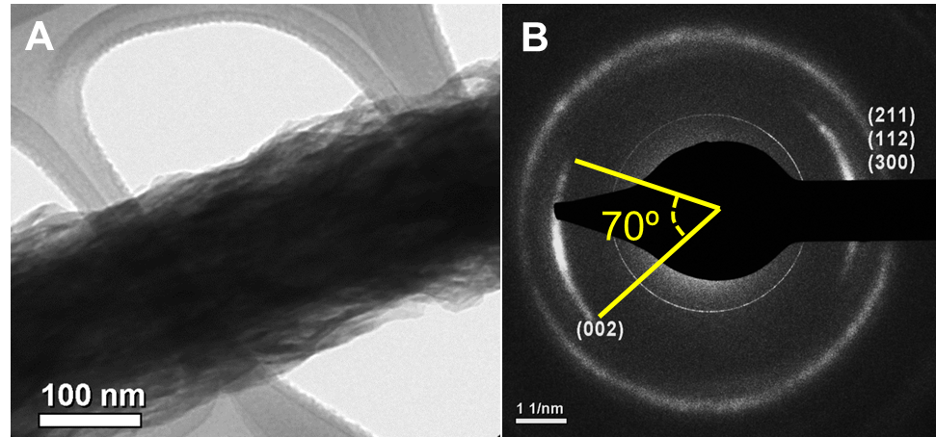

Figure S3. Highly mineralized collagen fibrils. A typical TEM image (A) and selected area electron diffraction pattern (B). Arcs of plane (002) are larger than 70° consistent with the
outwardly-directed subfibrils.

