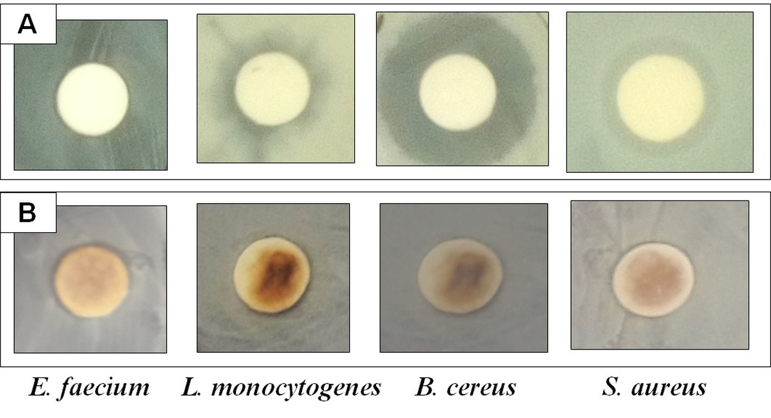S2 Fig: Antibacterial activity of (A) Standard positive control, gentamycin and (B) AC-AgNPs against the pathogenic bacteria.

