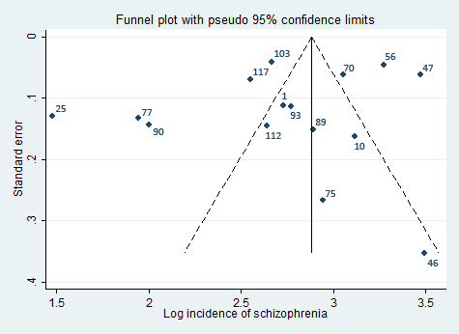
Figure S3: Funnel plot of log incidence rates of schizophrenia in relation to study size

