Figure S2: Bland Altman plot showing concordance of methods for collecting gestational age data

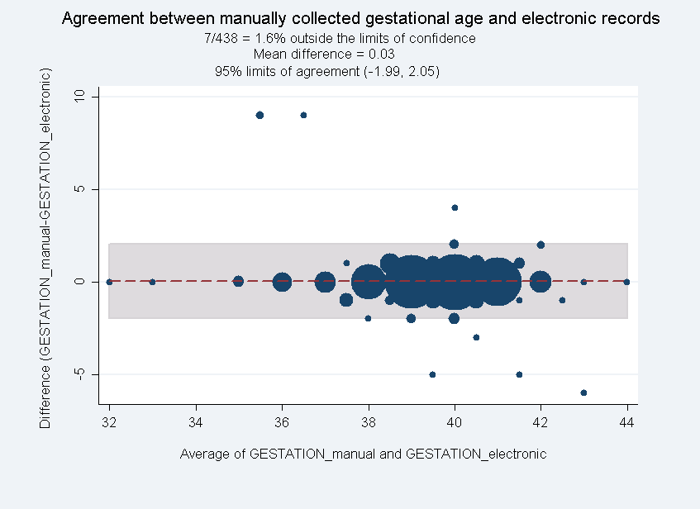
(wks)
(wks)

