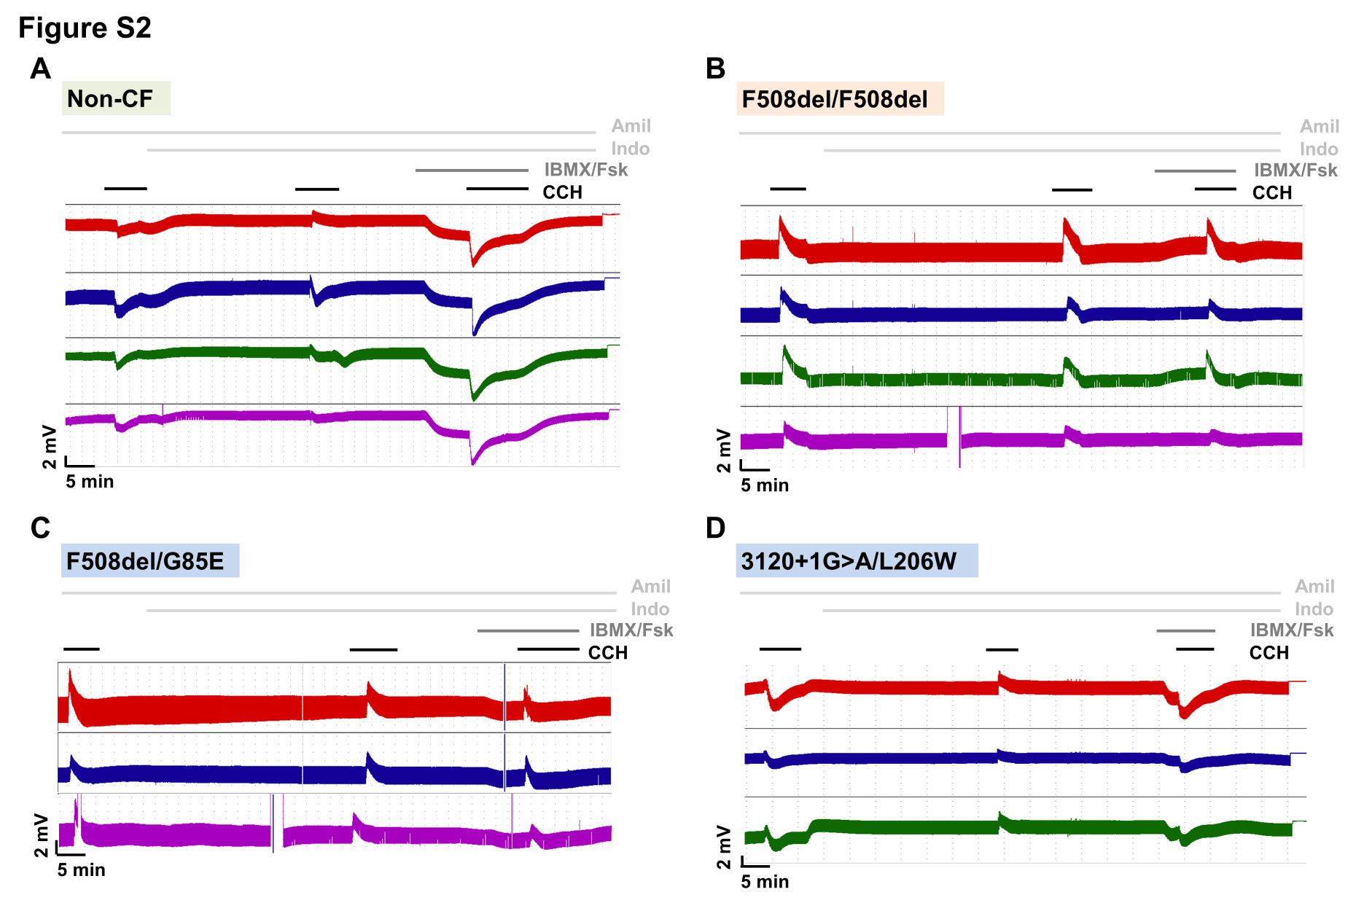
Figure S2 – Original recordings of transepithelial voltage (V_{te}) measurements in Ussing chambers obtained in 3-4 rectal biopsies from the same individual evidencing the high reproducibility of the method. Rectal biopsies from (A) Non-CF individual showing large cholinergic (carbachol, CCH, 100 µM, basolateral) and cAMP-dependent (3-isobutyl-1-methylxantine, IBMX, 100 µM, and forskolin, Fsk, 2µM, basolateral) Chloride (Cl⁻) secretion (lumen-negative responses); (B) CF patient homozygous for F508del-CFTR mutation with absence of Cl⁻ secretion (only lumen-positive responses, reflecting potassium (K⁺) secretion, were observed); (C) CF patient (genotype: F508del/G85E-CFTR) showing very little (~12%) cAMP-dependent Cl⁻ secretion (biphasic responses observed upon co-cholinergic stimulation with CCH); and (D) CF patient (genotype: 3120+1G>A/L206W-CFTR) presenting larger CFTR residual function (~57%) and milder phenotype than in (C). All the experiments were performed in the presence of Amiloride (Amil, 20 µM, luminal) and Indomethacin (Indo, 10 µM, basolateral). Transepithelial resistance (R_{te}) was determined from V_{te} deflections obtained by pulse current injection (0.5 µA).

