Figure S4
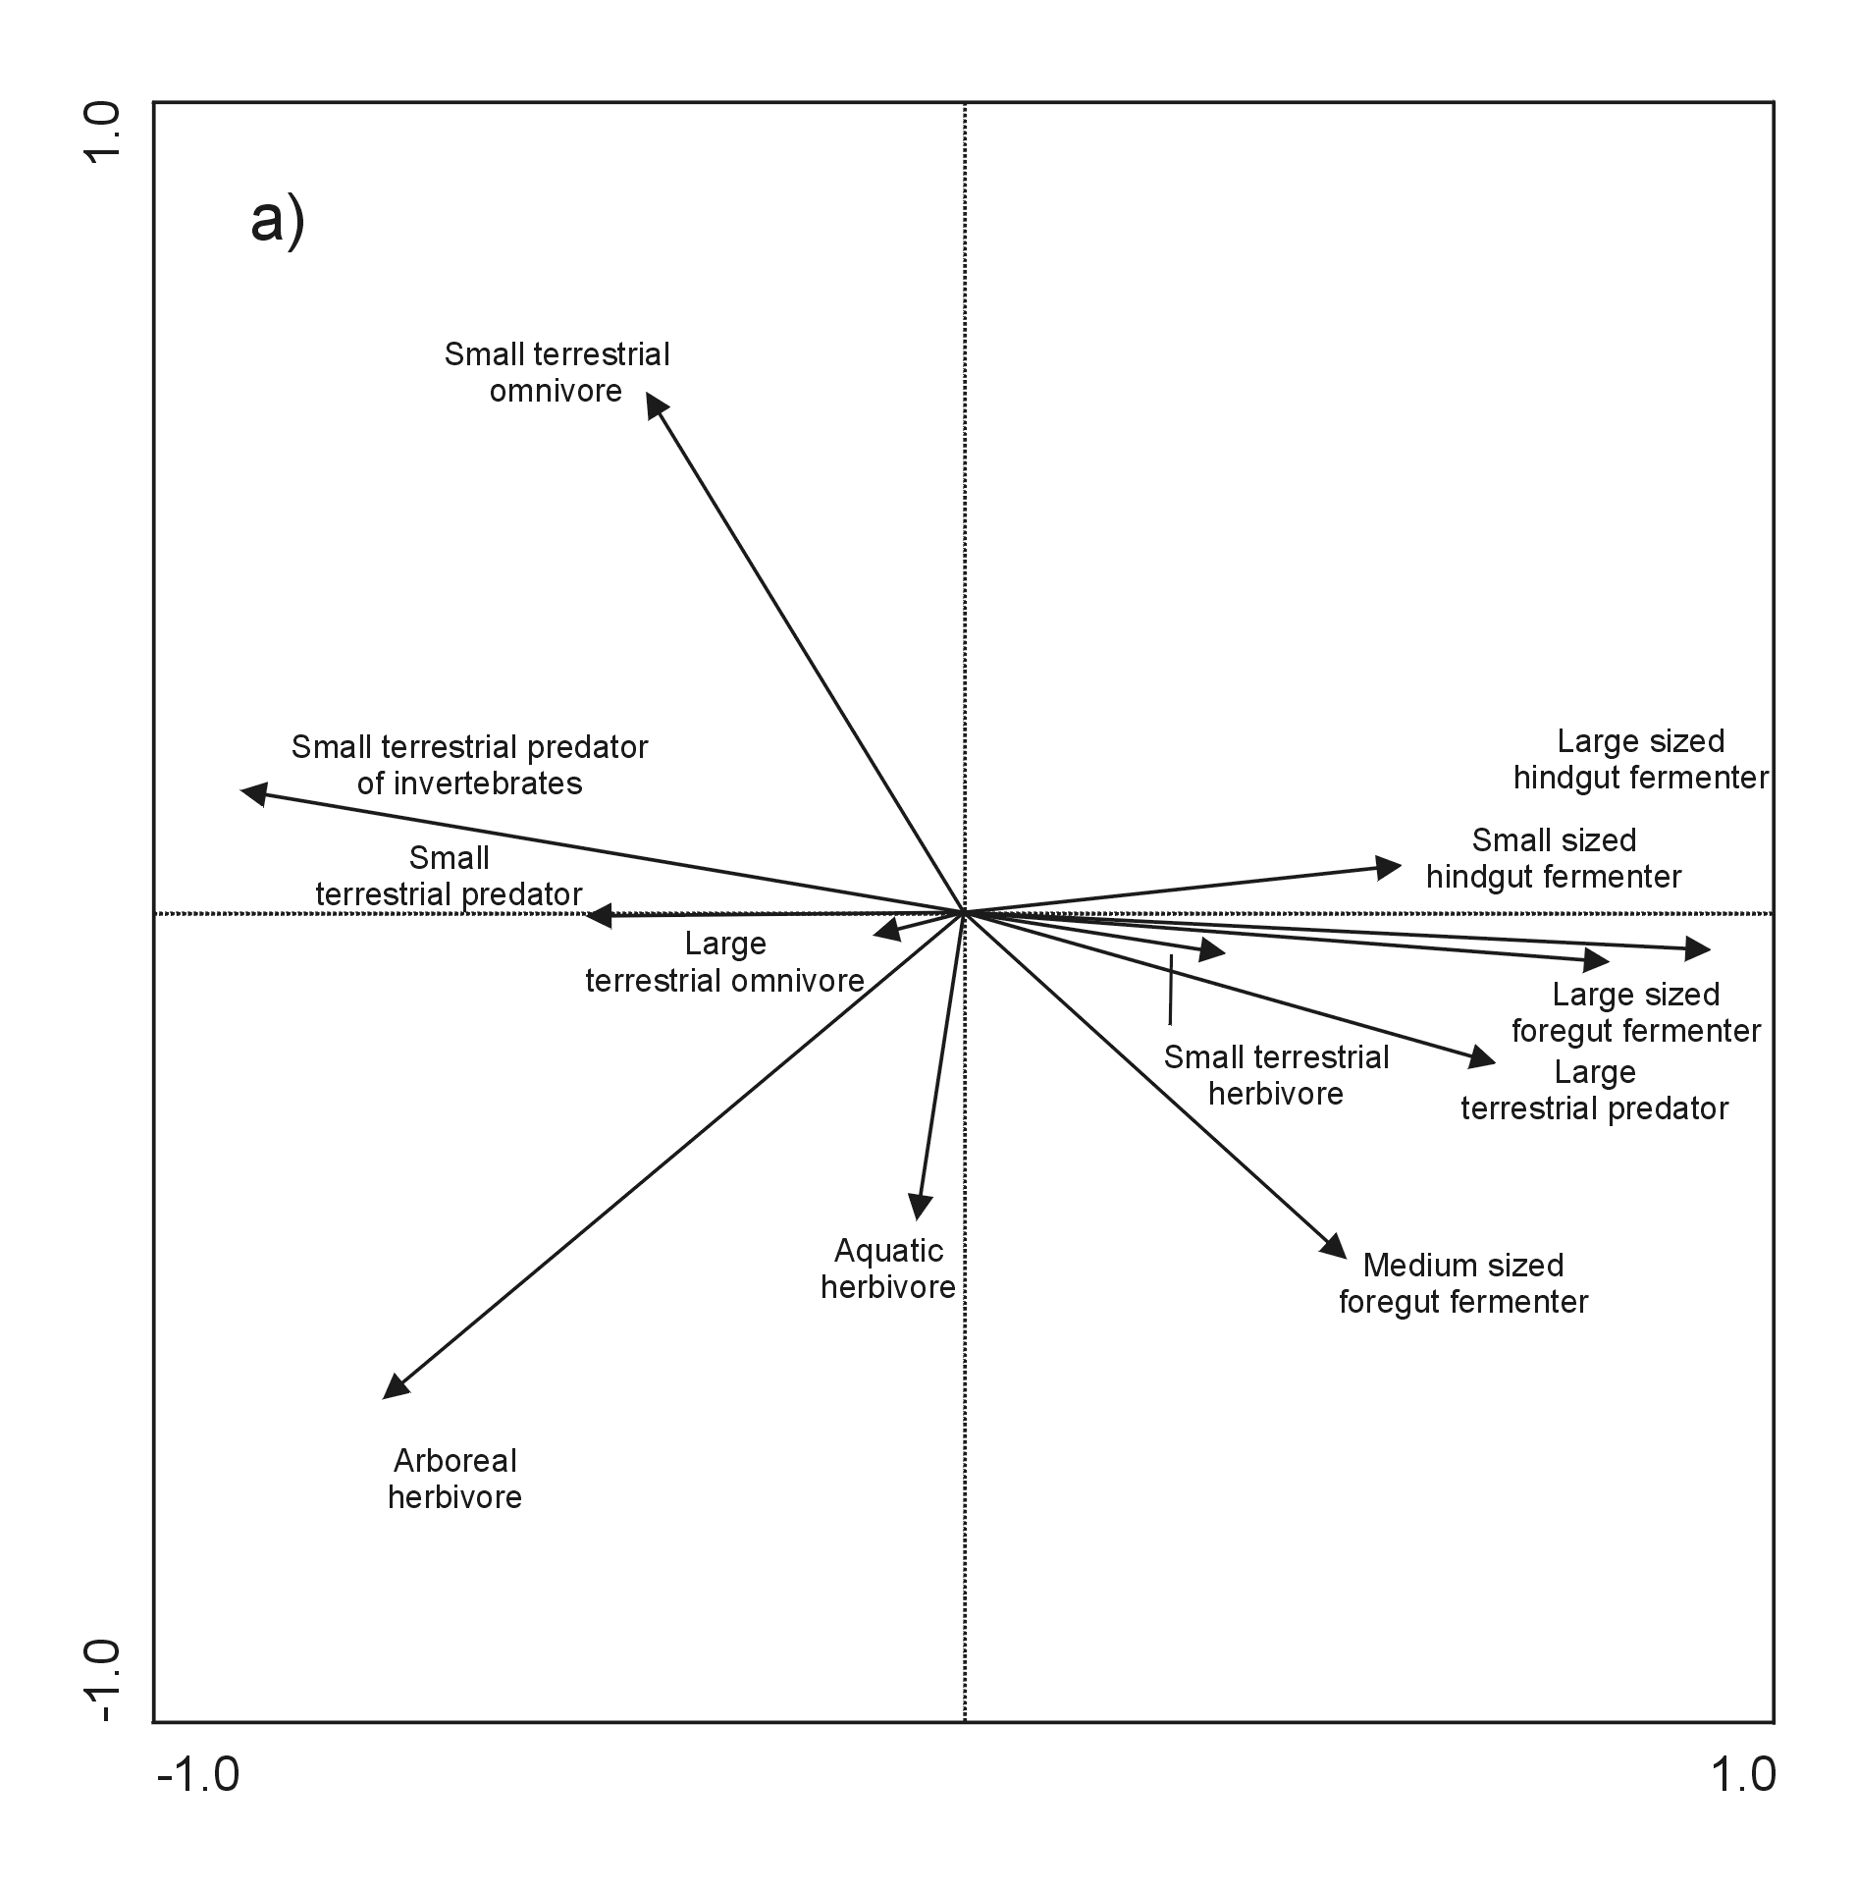

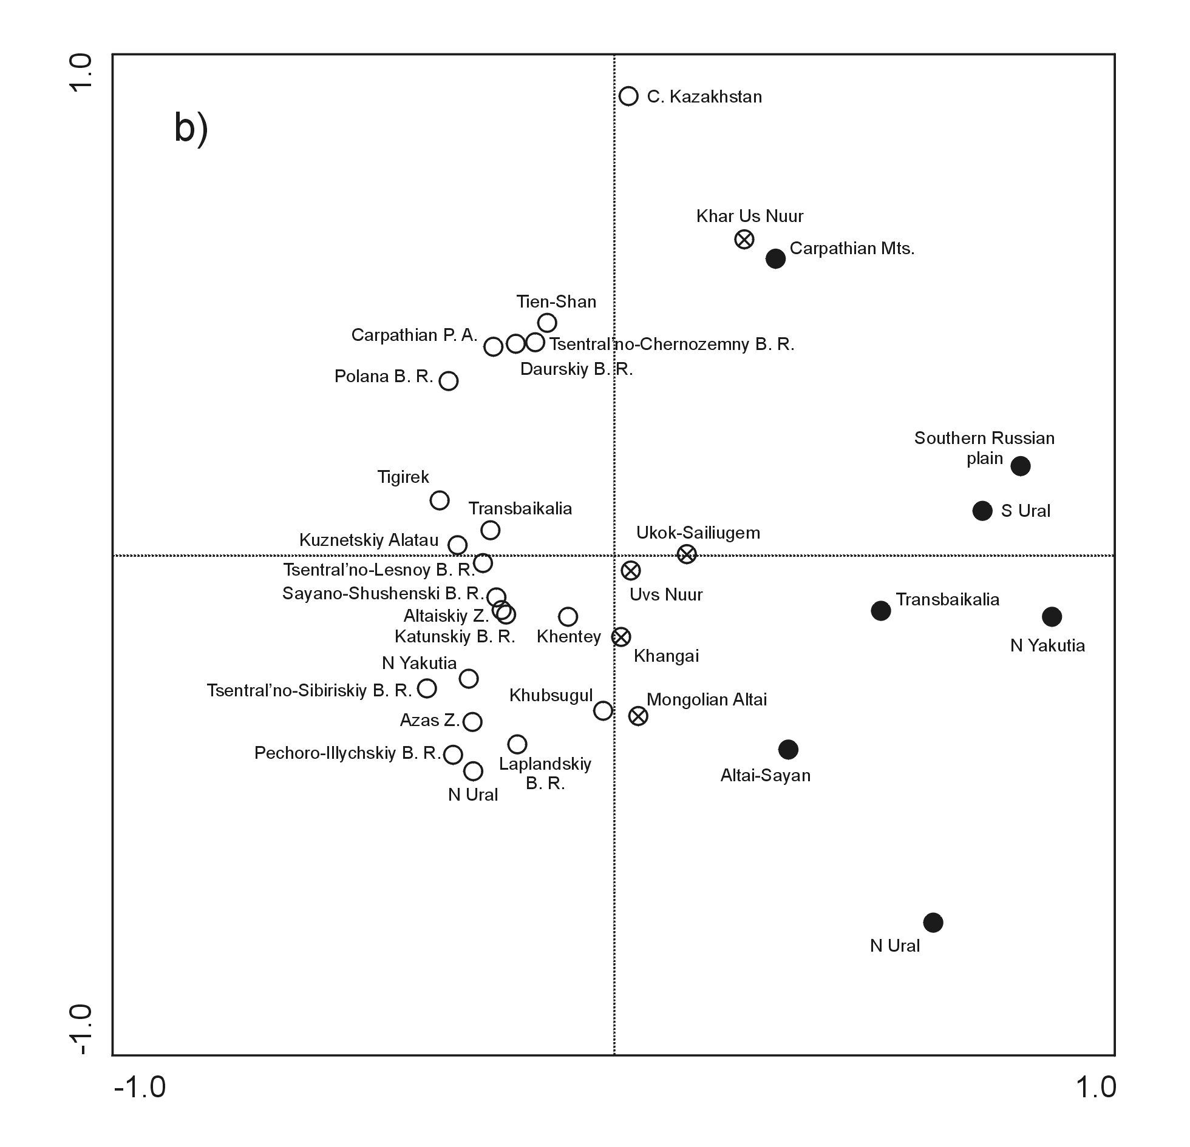

Fig. S4 The projection scores of studied localities according to trophic-sizes (PCA analysis without rare categories - aquatic predator, aquatic predator of invertebrates, subterranean predator of invertebrates, arboreal omnivore, small-sized foregut fermenter, subterranean herbivore), a) projection of trophic-sizes, b) projection of localities. Open circles – Recent assemblages; crossed circles – Recent eastern Altai assemblages; full circles – Last Glacial assemblages

